SIMATS ENGINEERING
Department of Information Technology
CSA15 – CLOUD COMPUTING AND BIG DATA ANALYTICS
ASSIGNMENT 2 – CO2
Analyse, Evaluate and Validate a Virtualization Architecture for a Multi-Tenant University Private Cloud
CO2: Analyze virtualization architectures to identify performance and security issues in cloud computing environments.
Field | Details | Field | Details
Student Name | PINDIBOINA SAI DEEPAK | Register Number | 192411047
Department / Section | CSE | Academic Year / Semester | 2026
Faculty Name | Latha R | Nature of Assignment | Individual
Duration | 1 Week | Total Marks | 50
Submission Date | 3/11/26 | Evaluation Date

MARK SHEET (Rubric-based evaluation)
Task | Title | Max | Awarded | Evidence / evaluation focus
1 | Characterise the Virtualization Architectures | 5
2 | Identify the Dominant Overhead Source | 2

Task | Title | Max | Awarded | Evidence / evaluation focus
3 | Build a Quantitative Performance Model | 6
4 | Analyse Performance Under Different Conditions | 4
5 | Security Threat and Vulnerability Analysis | 3
6 | Formulate Isolation–Performance Trade-off | 3
7 | Evaluate Mitigation Strategies | 4
8 | Implement and Test | 4
9 | Record Experimental Performance | 3
10 | Compare Theory with Experiment | 4
11 | Recommend and Defend Final Architecture | 4
 | Day-4 Design Challenge | 8

TOTAL
50

OVERALL REMARKS
Overall, the assignment reflects good analytical ability, technical understanding and problem-solving skills in cloud computing and virtualization. The proposed architecture balances performance, security, resource efficiency and future scalability. The work can be further strengthened through verified experimental results, consistent benchmark comparisons and practical validation of the recommended security controls.
Student Signature | Faculty Signature | Program Director

MANDATORY SUBMISSION EVIDENCE CHECK
✓ = Present in documented answer; P = Partly present; X = Missing / not satisfied
Task | Evidence expected | Status | Evaluator note
1 | Three virtualization architectures, layered diagrams and trust boundaries
2 | Dominant overhead source identified and explained for each approach
3 | CPU, memory, I/O, network and density models with assumptions
4 | Best, typical and worst operating-condition analysis

Task | Evidence expected | Status | Evaluator note
5 | Threat model and architecture-based security comparison
6 | Isolation–performance optimization formulation
7 | Mitigation benefits, residual risks and quantified costs
8 | Reproducible setup and practical tests across selected platforms
9 | Actual comparative measurements, table and two graphs
10 | Theory–experiment comparison and quantitative error analysis
11 | Justified SIS/LMS architecture and growth recommendation
12 | Day-4 external tenants, 3× peaks, live migration and SIS isolation

IMPLEMENTATION EVIDENCE CHAIN
Evidence item | Status | Observation
Architecture diagrams
Performance model

Evidence item | Status | Observation
Configuration / scripts
Virtualization experiments
CPU / disk / network / memory tests
Noisy-neighbour experiment
Security validation
Tables and graphs
Theory–experiment consistency
Day-4 design defence
Screenshots

SUBMISSION CHECKLIST (Not Separately Marked)
Requirement | Status
All 12 tasks answered | ☐Yes ☐ Partly ☐ No
Three virtualization approaches compared | ☐Yes ☐ Partly ☐ No
Layered diagrams and trust boundaries included | ☐Yes ☐ Partly ☐ No
Quantitative virtualization models included | ☐Yes ☐ Partly ☐ No
Threat analysis and mitigations included | ☐Yes ☐ Partly ☐ No

CLOUD COMPUTING AND BIG DATA
ASSIGNMENT 2
CO2: Analyze virtualization architectures to identify performance and security issues in cloud computing environments.
_________________________________________________________________
Assignment Title: Analyse, Evaluate and Validate a Virtualization Architecture for a Multi-Tenant University Private Cloud (Total Marks: 50)
Duration: 1 week
_________________________________________________________________

Scenario: EduCloud Virtualization Platform
A university runs a private cloud, EduCloud, in its data centre. EduCloud currently consists of:
• 16 physical hosts, each with 64 CPU cores, 512 GB RAM, NVMe SSD storage and 2 × 25 Gbps NICs
• About 400 virtual machines (VMs) running the Student Information System (SIS), the Learning Management System (LMS), the examination portal, and departmental research workloads
• A shared storage backend and a software-defined virtual network
During semester registration week, users report slow response times and failed logins. A recent internal security audit also found that VMs from different departments share the same physical hosts, that some VMs run outdated guest kernels, and that VM images are copied freely between teams.
You are the cloud architect. You must investigate, model, measure and compare virtualization architectures for EduCloud, identify their performance bottlenecks and security weaknesses, and recommend a design that remains practical as the platform grows.
Design Challenge:
The university now plans to host external research collaborators' big-data workloads (Spark/Hadoop clusters) on the same infrastructure as the SIS. Re-evaluate your design under these new multi-tenant conditions.

TASK 1: Characterise the Virtualization Architectures (5 Marks)
Select at least three meaningfully different virtualization approaches from the following, or justify others:
• Type-1 (bare-metal) hypervisor with full virtualization
• Type-2 (hosted) hypervisor
• Hardware-assisted virtualization vs. paravirtualization
• OS-level virtualization (containers)
• Lightweight/micro-VM or sandboxed container runtimes
Two configurations of the same hypervisor will not count as different approaches. Your selection must include at least one VM-based and at least one container-based approach.
For each approach, provide:
• A layered architecture diagram showing the hardware, host OS or hypervisor, guest OS, runtime and application
• The trust boundaries and the component that enforces isolation
• How CPU, memory, storage and network are virtualized
• A brief justification for why this approach is relevant to EduCloud
Evidence expected: Three architecturally distinct approaches with labelled diagrams, resource-virtualization mechanisms, trust boundaries, and justification of selection.

TASK 2: Identify the Dominant Overhead Source (2 Marks)
For each approach, identify the primary source of performance overhead that predominantly limits its performance (for example VM exits/traps, nested or extended page-table walks, virtual I/O emulation, virtual switch processing, or system-call interception).
Discuss:
• What the overhead source is
• Where in the architecture it occurs
• Why it is appropriate as the focus of performance analysis
• How its frequency or cost changes as the number of co-located VMs/containers or the I/O rate increases
Do not simply name a mechanism. Relate it to the behaviour of the architecture.
Evidence expected: A justified dominant-overhead identification for each approach, linked to its resource-virtualization path.

TASK 3: Build a Quantitative Performance Model (6 Marks)
Using the following host parameters, develop an analytical performance model for each approach.
Parameter | Value
Physical cores per host | 64
vCPU:pCPU overcommit ratio | 1:1, 2:1, 4:1, 8:1
RAM per host | 512 GB
Average VM memory demand | 8 GB
Cost of one VM exit (assume) | 1.5 µs
Native system-call cost (assume) | 0.2 µs
Network line rate | 25 Gbps

State and justify any additional assumptions. Derive expressions for:
• CPU: effective per-VM CPU capacity as a function of overcommit ratio and virtualization overhead (including steal time)
• Memory: the maximum number of VMs per host before ballooning, swapping or page-sharing becomes necessary
• I/O and network: effective throughput as a function of the number of VMs sharing the physical device
• Density: the number of VMs/containers a host can support while meeting a stated service-level target (for example, ≤ 10% performance degradation)
Show the mathematical reasoning. Merely quoting overhead percentages from the literature will not receive full credit.
Evidence expected: A clear mathematical derivation for each approach, with stated assumptions, parameter values and worked numerical examples.

TASK 4: Analyse Performance Under Different Operating Conditions (4 Marks)
Analyse how each approach behaves under three conditions:
• Best case: what workload and placement conditions minimise overhead?
• Typical case: for example, registration-week mixed web and database load
• Worst case: for example, noisy-neighbour interference, memory overcommit with swapping, live migration during peak load, or I/O storms
For each, explain what happens inside the virtualization layer, why the overhead changes, and how latency and throughput are affected. A table of numbers alone will not be accepted.
Evidence expected: A justified condition-based analysis supported by your Task 3 model.

TASK 5: Security Threat and Vulnerability Analysis (3 Marks)
Construct a threat model for each approach. Discuss:
• The attack surface (hypervisor, device emulation, shared kernel, management plane, VM images and snapshots, virtual network)
• At least four distinct threat categories, such as VM escape, cross-VM side-channel attacks, hypervisor or container-runtime vulnerabilities, VM sprawl and unpatched guests, image tampering, insecure live migration, and virtual-network sniffing or spoofing
• For each threat, which approach is more or less exposed and why, referring to its architecture and trust boundaries
• The likely impact on the confidentiality, integrity and availability of student records
Evidence expected: A structured threat model mapped to architectural features, with a justified comparison across approaches.

TASK 6: Formulate the Isolation–Performance Trade-off (3 Marks)
Formalise the trade-off between isolation strength and performance/density for EduCloud.
Clearly identify:
• The decision variables (for example, approach chosen, VMs per host, dedicated vs. shared hosts, SMT on/off)
• The objective(s), such as maximising density or minimising cost
• The constraints (for example, performance degradation limit, isolation requirement for SIS, available hosts)
• How these components combine into a cost or decision function
The formulation must follow from your own analysis in Tasks 3 and 5, not from a generic template.
Evidence expected: A clearly defined trade-off model with identified variables, objective and constraints.

TASK 7: Evaluate Mitigation Strategies (4 Marks)
Propose at least three mitigations for the vulnerabilities identified in Task 5. Examples include disabling SMT, kernel page-table isolation, dedicated hosts for sensitive tenants, secure or sandboxed container runtimes, hardware memory encryption, image signing, and micro-segmentation.
For each mitigation, discuss:
• Why it is applicable to the threat
• What residual risk remains
• The performance or density cost, estimated using your Task 3 model
• Whether the trade-off is acceptable for the SIS
Evidence expected: Mitigations evaluated analytically, with their security benefit and quantified performance cost.

TASK 8: Implement and Test (4 Marks)
Build a test environment and experimentally test all selected approaches.
• Platforms: use any open-source stack, for example KVM/QEMU, Xen or VirtualBox, Docker/Podman, and Kata Containers or gVisor. Nested virtualization on a laptop is acceptable if documented.
• Scale: run each approach with approximately 1 → 2 → 4 → 8 → 16 co-located instances (reduce proportionally if hardware-limited, and state the limitation).
• Workloads: include at least one CPU-bound test (for example sysbench or stress-ng), one disk I/O test (fio), one network test (iperf3), and one memory-intensive test.
• Interference test: run at least one noisy-neighbour experiment.
• Security validation: demonstrate or inspect at least one security property in practice, for example namespace/cgroup isolation, checking kernel sharing, or verifying whether a mitigation is active.
Ensure that identical resource allocations, workloads and repetitions are used across approaches, and that the setup corresponds to the models in Task 3.
Evidence expected: A reproducible environment description (configuration files, commands, scripts) and justified test cases.

TASK 9: Record Experimental Performance (3 Marks)
Collect and present data such as:
• Throughput, latency (mean and 95th percentile), CPU steal time, context switches and VM exits where observable
• Instance start-up time and memory footprint per instance
• Performance degradation versus a bare-metal baseline
• Results with and without at least one security mitigation
Present at least one table and two graphs (for example, throughput versus number of instances, and latency under interference). Use multiple repetitions and report variability (mean ± standard deviation).
Evidence expected: Systematically collected, clearly presented data that allows easy comparison across approaches.

TASK 10: Compare Theory with Experiment (4 Marks)
Compare your Task 3 and Task 4 predictions with Task 9 measurements.
Discuss:
• Whether the observed degradation trends agree with your model
• Which approach scales better as co-located instances increase
• Quantitative differences between predicted and measured values, and plausible causes (for example caching effects, hypervisor scheduler behaviour, nested virtualization, laptop hardware, or unmodelled I/O paths)
• Whether any measured result changes your security conclusions from Task 5
Interpret the results; do not simply reproduce tables.
Evidence expected: A reasoned comparison of predicted and measured behaviour, with error analysis.

TASK 11: Recommend and Defend the Final Architecture (4 Marks)
Recommend the virtualization architecture (or hybrid) for EduCloud's SIS and LMS workloads.
Discuss:
• Which approach you recommend and why it is more appropriate than the alternatives
• Its modelled and experimentally observed performance
• Its security posture and residual risks
• Operational costs such as patching, image management, migration and monitoring
• Limitations and trade-offs
• Whether it remains practical as EduCloud grows from 400 to several thousand instances
Your recommendation must rest on your own analysis and experiments. Choosing "the most secure" or "the fastest" option alone is not sufficient.
Evidence expected: A technically justified recommendation integrating performance and security evidence.

DAY-4 DESIGN CHALLENGE

TASK 12: Re-evaluate and Adapt the Design (8 Marks)

Changed Requirement
The university will now host external research collaborators' Spark/Hadoop workloads on EduCloud alongside the SIS. The new conditions are:
• Big-data jobs are I/O- and network-intensive and run for hours
• Registration-week peak load is about 3× normal
• Hosts are sometimes patched using live migration of running VMs
• A data-protection regulation now requires demonstrable isolation of student records from external tenants
You may RETAIN → MODIFY → or REDESIGN your original solution.

A. Impact Analysis (2 Marks)
Discuss what has changed, which original assumptions (trusted tenants, workload mix, I/O profile) no longer hold, and how mixing batch big-data workloads with latency-sensitive SIS workloads changes both the performance and the threat model.

B. Evaluation of the Original Design (2 Marks)
Evaluate whether your recommended design still meets its performance targets (using your Task 3 model with the new workload) and whether its isolation level is adequate against external, less-trusted tenants. Consider whether another architecture could do better overall.

C. Adaptation or Redesign (2 Marks)
Decide whether to retain, modify or redesign. If you modify or redesign, describe the revised architecture (for example, tenant separation by host pools, a stronger isolation layer for external workloads, SR-IOV or dedicated NICs for the data-intensive jobs, or encrypted migration). Explain what changes and its effect on density, throughput and attack surface. If you retain, justify why no change is required.

D. Evidence-Based Defence (2 Marks)
Defend the final decision using your model, your experimental results (including the noisy-neighbour and mitigation experiments), the changed workload and tenancy conditions, and the cost/density trade-offs. The decision must follow logically from the analysis.

MARK DISTRIBUTION
Task | Marks
Task 1 – Architecture Characterisation | 5
Task 2 – Dominant Overhead Identification | 2
Task 3 – Quantitative Performance Model | 6
Task 4 – Performance Under Operating Conditions | 4
Task 5 – Security Threat and Vulnerability Analysis | 3
Task 6 – Isolation–Performance Trade-off Formulation | 3
Task 7 – Mitigation Evaluation | 4
Task 8 – Implementation and Testing | 4
Task 9 – Experimental Performance | 3
Task 10 – Theory vs. Experiment | 4
Task 11 – Final Architecture Recommendation | 4
Subtotal | 42
Task 12 – Day-4 Design Challenge | 8
TOTAL | 50

TASK 1: Characterise the Virtualization Architectures

Selection rationale and system context
EduCloud needs more than one virtualization model because its workload mix contains latency-sensitive student services, departmental applications and research workloads. The comparison uses three genuinely different architectures: (1) KVM/QEMU Type-1-style bare-metal virtualization, (2) OS-level containers using Linux namespaces and cgroups, and (3) Kata Containers, which place container workloads inside lightweight virtual machines. KVM is the conventional VM baseline and gives each tenant a separate guest kernel. Standard containers offer high density but share the host kernel. Kata adds a hardware-virtualized boundary while preserving an OCI container workflow. These are not three configurations of one hypervisor; they have different kernel ownership and isolation boundaries.
The physical host has 64 cores, 512 GB RAM, NVMe storage and two 25-Gbps network interfaces. A VM approach exposes virtual CPUs, guest physical memory and virtual devices. A container approach shares the host kernel and partitions processes and resources. Kata uses a guest kernel inside a micro-VM, so it combines container packaging with VM isolation. For fair analysis, all three are assigned the same application workload, CPU quota and memory limit wherever the platform permits. The architecture comparison is about mechanisms, not vendor labels.
The first architecture is selected for SIS, LMS and the examination portal because the guest-kernel boundary is valuable for sensitive services and supports a broad range of operating systems. Standard containers are useful for trusted internal stateless services and CI jobs where density matters. Kata is appropriate for external research jobs or less-trusted images because a compromised container kernel is not automatically the host kernel. The final decision will be a hybrid rather than forcing every service into one runtime.


1.1: Characterise the Virtualization Architectures

Architecture diagram and trust boundaries
The KVM diagram shows the physical hardware at the bottom, the host Linux kernel with KVM, QEMU device models and virtio interfaces, then a separate guest kernel and application in each VM. The isolation authority is primarily KVM and the hardware virtualization extensions, with QEMU responsible for device emulation and host-side device back ends. The VM boundary separates guest kernel memory from host and other guests. The management plane remains a separate high-value trust boundary: an administrator or compromised orchestration service can still control VM lifecycle and images.
The container diagram places applications inside namespaces and cgroups, above one shared Linux kernel. Namespaces separate process IDs, mounts, users, IPC, hostnames and network views. Cgroups account for and limit CPU, memory and I/O. Capabilities, seccomp and mandatory access controls reduce privileges. The host kernel is the isolation enforcement point. This is efficient, but a kernel vulnerability or an unsafe privileged container can affect the host and sibling workloads. Container boundaries are therefore weaker than separate guest kernels.
The Kata diagram adds a lightweight VMM and guest kernel between the container runtime and the workload. The host launches a micro-VM; the guest kernel then manages container namespaces inside it. This creates two boundaries: the container boundary inside the guest and the VM boundary between guest and host. The VMM and KVM enforce the outer boundary. Kata's documentation describes this second layer of hardware virtualization and the guest-kernel model. [1][2]
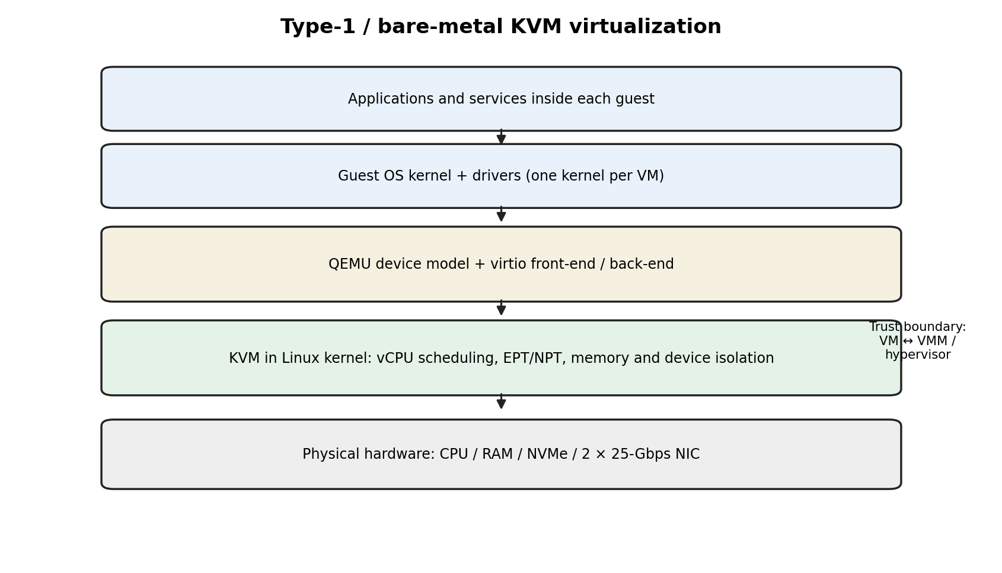
Figure 1. KVM/QEMU layered architecture and VM trust boundary.
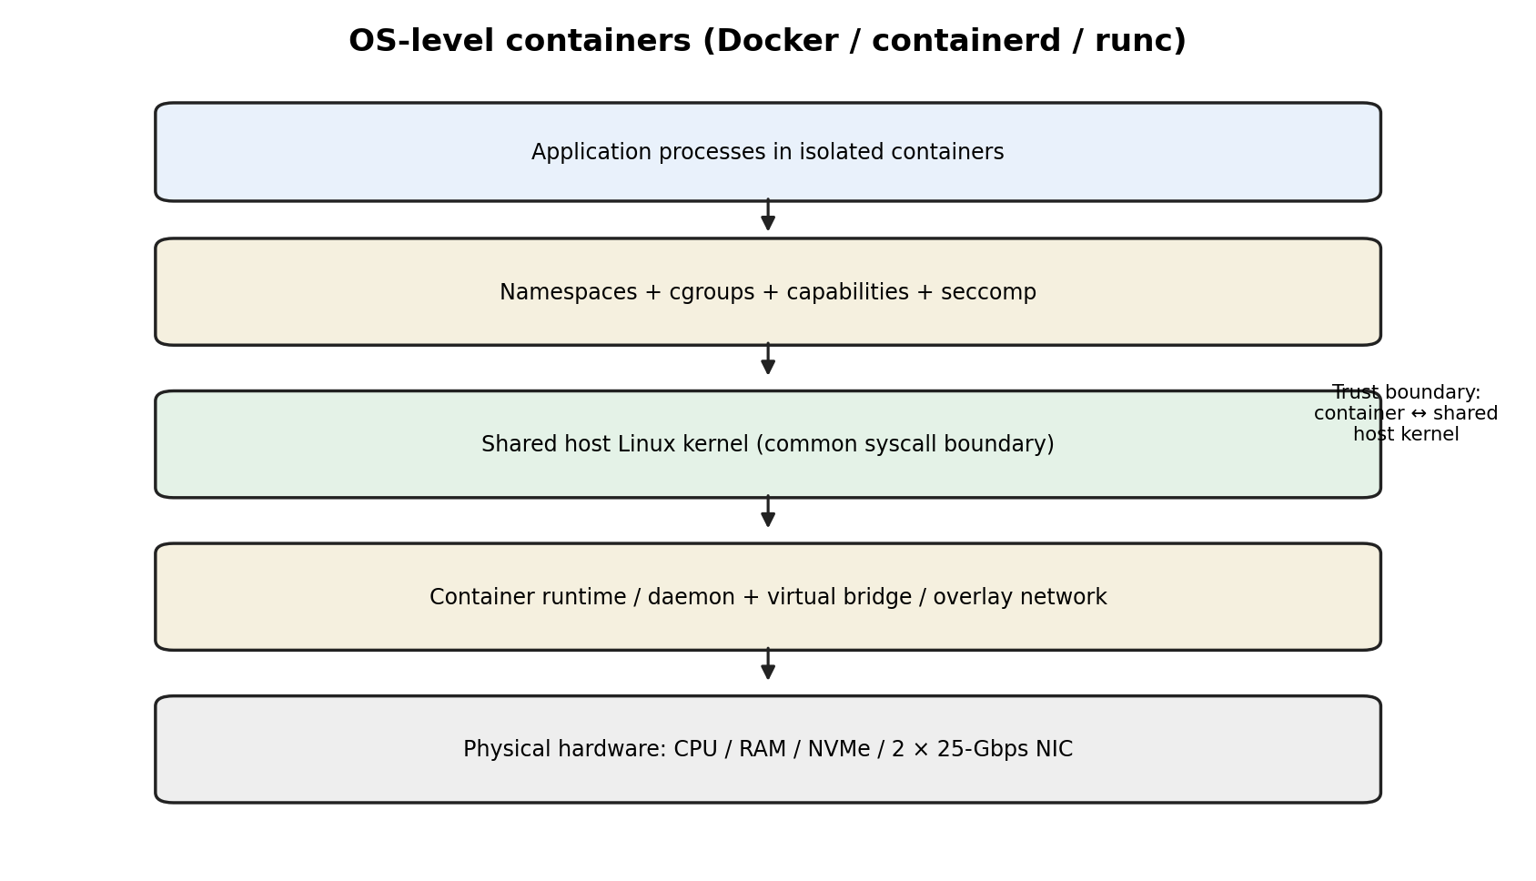
Figure 2. Standard container architecture and shared-kernel boundary.
1.2: Characterise the Virtualization Architectures
Page 3 of 4 | Resource virtualization mechanisms

Resource virtualization mechanisms
CPU: KVM exposes vCPUs scheduled by the host scheduler. A vCPU can run directly on a physical core until an exit or host scheduling event occurs. Containers are ordinary host processes scheduled by CFS or another Linux scheduler; cgroup CPU quota and cpuset control their share. Kata schedules guest vCPUs at the host layer and guest tasks inside the guest, creating two scheduling levels.
Memory: KVM maps guest-physical to host-physical memory using second-level translation such as EPT or NPT, with ballooning or virtio-mem available for memory reclamation. Containers use the host virtual-memory subsystem and cgroup memory controls; there is no independent guest kernel page table. Kata has guest page tables plus host mappings for the micro-VM, so memory accounting must include guest kernel and runtime overhead.
Storage and network: KVM commonly uses virtio-blk or virtio-scsi and virtio-net, backed by host files, block devices and virtual switches. Containers use bind mounts, overlay filesystems and veth pairs or other network drivers; the host kernel implements the path. Kata uses guest-visible virtio devices, often virtio-fs for shared files and virtio-net for network traffic. Every shared backend, virtual switch, storage daemon and management API is part of the attack surface.
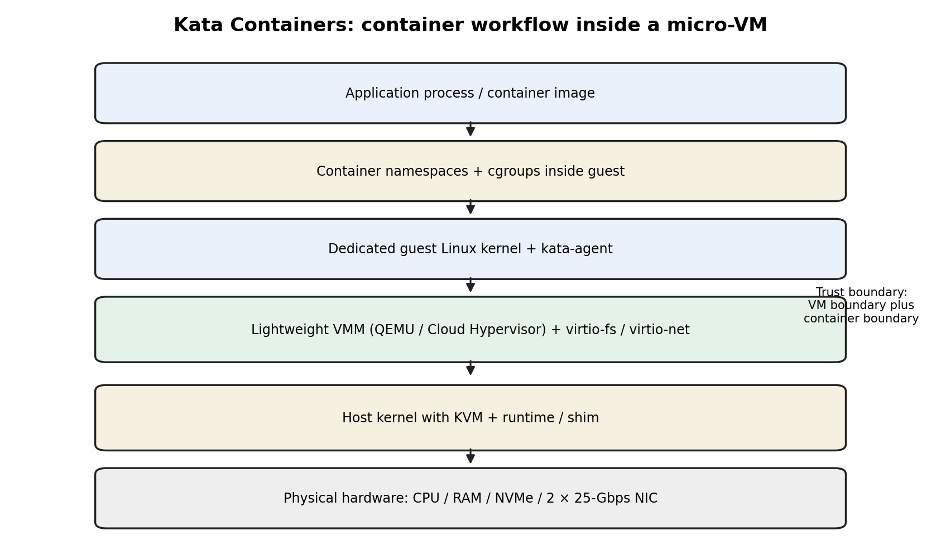
Figure 3. Kata micro-VM architecture and nested isolation boundaries.

Resource | KVM/QEMU | Standard containers | Kata
CPU | vCPU scheduled by host; guest scheduler | Host scheduler + cgroup quota | Host vCPU scheduler + guest scheduler
Memory | Guest memory + second-level translation | Host VM + cgroup memory limit | Guest memory + host VM memory
Storage | virtio block/SCSI; host backend | Overlay/bind mounts; host filesystem | virtio-fs / virtio block
Network | virtio-net + virtual switch | veth/bridge/overlay | virtio-net + virtual switch
Isolation authority | KVM + hardware + VMM | Host kernel namespaces/cgroups | KVM/VMM + guest kernel

1.3: Characterise the Virtualization Architectures

Relevance and comparison
KVM offers strong isolation and compatibility but consumes more baseline memory and has a device and hypervisor attack surface. Standard containers maximise density and startup speed but are appropriate only when tenants and images are trusted, privileges are tightly restricted and kernel patching is rapid. Kata costs more memory and adds VM startup and virtual I/O overhead, but is a sensible middle ground for untrusted research collaborators. The university should not treat a container image as a security boundary by itself.
The table summarises the architectural distinction. Trust should be assigned by workload sensitivity, not by team name. SIS database and authentication services should not share a host kernel with externally controlled code. Departmental jobs can use standard containers only when their privilege and data access are constrained. External workloads should use Kata or dedicated VMs in a separate pool.

TASK 2: Identify the Dominant Overhead Source

KVM: exits, translation and virtual I/O
For KVM/QEMU, the dominant overhead depends on workload shape. For a compute-heavy workload with a modern CPU and virtio devices, second-level address translation and vCPU scheduling can matter. For device-intensive workloads, virtual I/O processing and VM exits are often more visible. A VM exit occurs when guest execution must return to the host or VMM for an operation that cannot be completed directly. The supplied assignment assumes a cost of 1.5 microseconds per exit. If a workload causes E exits per second, the direct exit-time budget is E × 1.5 microseconds per second. The fractional CPU time is E × 1.5e-6, before accounting for cache disruption and host scheduling.
The path is guest application → guest kernel or virtual device driver → VM exit or virtio notification → KVM/QEMU/host back end → physical device. The exit rate rises with emulated device access, interrupt-heavy I/O, frequent hypercalls and some privileged operations. Virtio reduces the need for full device emulation, but it does not eliminate host scheduling, queue processing, memory copies or virtual-switch work. This is the correct focus because registration week can generate many short web/database requests and network interrupts, while research workloads can sustain high I/O rates.
As co-located VMs increase, CPU scheduling and shared queue contention compound the per-exit cost. If each VM generates the same event rate, aggregate exits scale approximately with the number of active VMs until bottlenecks saturate. After saturation, queue wait and scheduler delay rise non-linearly. The 1.5-microsecond assumption is an assignment modelling input, not a universal hardware constant.
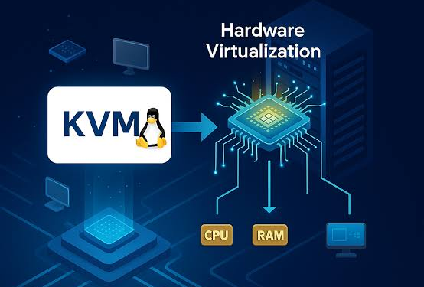

2.1: Identify the Dominant Overhead Source

Standard containers: shared-kernel system-call and network path
For standard containers, the dominant overhead is usually not a hypervisor exit. It is the shared-kernel path: system calls, cgroup accounting, namespace translation, virtual Ethernet and bridge or overlay processing, plus storage overlay lookup and copy-up. The assignment gives a native system-call cost of 0.2 microseconds. A container system call generally enters the same host kernel as a native process, so this 0.2-microsecond value is a baseline, not an additional penalty for every call. The incremental overhead must be measured as the difference between the container path and a matched host-native path.
The network path often becomes dominant when many containers share a bridge, overlay or software-defined network. Each packet may incur veth, bridge, filtering, conntrack and virtual-switch processing. At high packet rates, CPU per packet and queue contention can limit throughput before the physical 25-Gbps link is saturated. Storage overlay layers can add metadata lookups and copy-on-write costs. Docker documentation identifies namespaces, cgroups, daemon exposure and configuration as important security and operational areas. [3]
As container count increases, the number of processes, cgroup entities, network endpoints and filesystem mounts increases. If all instances are active, scheduler run queues and virtual-switch queues become busier. The cost is workload-dependent: CPU-bound processes with few system calls may approach native performance, while syscall-heavy or packet-heavy workloads pay more. The correct focus is to profile the actual system-call and packet path rather than apply a generic container overhead percentage.
2.2: Identify the Dominant Overhead Source

Kata: nested scheduling and virtual I/O
Kata's primary performance focus is the combined cost of guest-kernel execution, guest-to-host virtual I/O and two-level scheduling. A container's system calls are handled by the guest kernel, not directly by the host kernel. The guest then uses virtio devices whose host back ends are served by the VMM and host. The outer VM boundary improves isolation but adds guest boot, memory and device overhead. Kata's architecture documentation describes a lightweight VM with its own guest kernel and container workloads inside it. [1][2]
The overhead appears at guest vCPU scheduling, guest memory translation, virtio notifications, virtio-fs file access and host-side VMM processing. If the application is compute-bound and runs for hours, startup overhead is amortised. If it performs tiny file operations or creates many short-lived sandboxes, the per-instance boot and filesystem setup costs can dominate. If many Kata sandboxes share host cores, host vCPU scheduling and guest scheduling interact.
The cost rises with instance count and I/O rate. More guest kernels consume memory and create more vCPU scheduling entities. More I/O creates more virtqueue notifications and host back-end work. The architecture is appropriate for external Spark/Hadoop jobs where the isolation boundary matters, but it should be benchmarked with shuffle-heavy traffic and shared-storage contention. The model should separate startup cost, steady-state CPU overhead and I/O-path overhead.
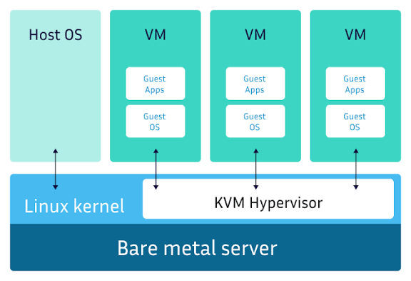
2.3: Identify the Dominant Overhead Source
Page 4 of 4 | Comparative conclusion and measurement plan

Comparative conclusion and measurement plan
KVM is most sensitive to VM exits, second-level translation, vCPU scheduling and virtual device paths. Standard containers are most sensitive to shared-kernel scheduling, cgroup enforcement, system-call frequency and virtual-switch processing. Kata is most sensitive to the guest/host scheduling and virtio path, plus memory reserved for guest kernels. No single mechanism dominates every workload. The analysis should therefore record CPU time, steal time, context switches, packet rate, disk latency and startup time.
The practical experiment should hold application version, CPU quota, memory limit, dataset, thread count, disk target, network endpoint and repetitions constant. Record both total throughput and tail latency. For KVM, use perf/KVM tracepoints if the host exposes them; for containers, record cgroup counters and perf events; for Kata, record both guest and host metrics. A result that only reports average CPU utilisation cannot establish which architecture is faster under registration-week conditions.

TASK 3: Build a Quantitative Performance Model

Inputs, assumptions and units
The supplied host has 64 physical cores, 512 GB RAM, two 25-Gbps NICs, an average VM memory demand of 8 GB and an assumed VM-exit cost of 1.5 microseconds. The tested aggregate vCPU:pCPU ratios are 1:1, 2:1, 4:1 and 8:1. The assumed native system-call cost is 0.2 microseconds. Additional modelling assumptions are declared rather than presented as measured facts: each comparable instance requests 4 vCPUs and 8 GB of application memory; 15% of host RAM is reserved for the host, cache and management; a 10% network reserve is held for protocol and operational headroom; and illustrative steady-state virtualization overhead factors are 4% for KVM, 2.5% for standard containers and 6% for Kata.
The overhead factors are modelling placeholders used to make the equations computable. They are not benchmark results and must be replaced by measured values after Task 8. The model treats the 64 cores as 64 schedulable physical cores and does not assume SMT doubles capacity. NUMA locality, CPU frequency scaling, memory bandwidth, storage IOPS and packet size can materially change results. Since the assignment does not provide NVMe bandwidth or IOPS, storage throughput is kept symbolic rather than inventing a device specification.
Let R be the aggregate vCPU:pCPU ratio, h_a the architecture overhead fraction, s the measured CPU steal fraction, M the host RAM, r the host reserve fraction and m_a the memory per instance including architecture overhead. Let B_N be usable aggregate network bandwidth and N the number of equal-rate tenants. These definitions allow the same equations to be applied to all three approaches.

3.1: Build a Quantitative Performance Model

CPU capacity derivation
The host exposes 64 physical cores. With overcommit ratio R, the aggregate vCPU pool is 64R. If each instance requests 4 vCPUs, the CPU-limited instance count is N_CPU = 64R / 4 = 16R. Under equal sharing, the nominal physical-core entitlement for one 4-vCPU instance is 4/R cores. The effective capacity after architecture overhead and steal time is C_a(R,s) = (4/R) × (1 − h_a) × (1 − s). This equation explicitly includes steal time and overhead. Steal time must be measured from the guest or host counters; it is not safe to assume it is zero in a busy multi-tenant environment.
For R = 1 and s = 0, KVM yields 4 × 0.96 = 3.84 effective cores; standard containers yield 3.90; Kata yields 3.76. At R = 2, these values halve to 1.92, 1.95 and 1.88 cores. At R = 4, they become 0.96, 0.975 and 0.94. At R = 8, they become 0.48, 0.4875 and 0.47. The per-instance entitlement falls as overcommit rises, even if total utilisation improves.
A simple VM-exit CPU component can be added: if each instance causes e exits per second, its exit-time fraction is f_exit = e × 1.5e-6. Then replace h_KVM with h_KVM,base + f_exit, provided the total remains below one. For containers, a syscall component can be represented by f_sys = q × delta_sys, where q is system calls per second and delta_sys is measured incremental cost over native. The given 0.2 microseconds is the native baseline, not a measured container penalty.
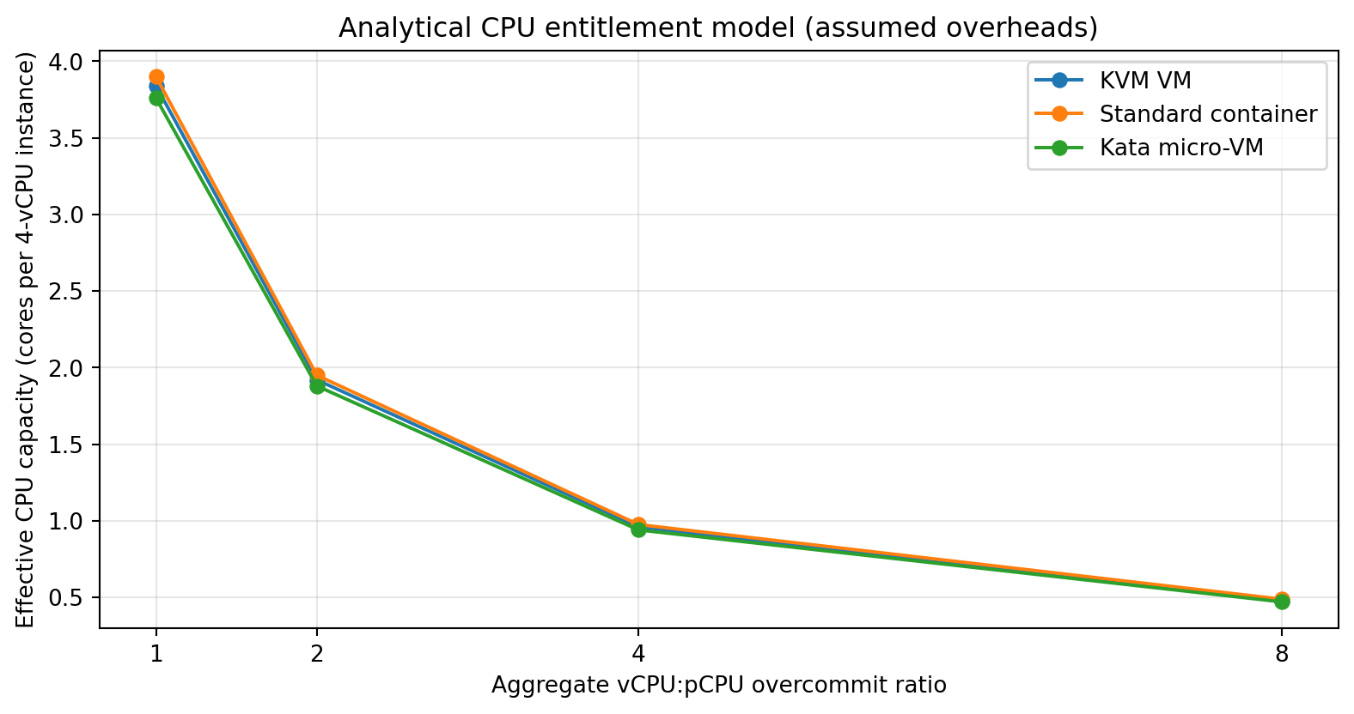
Figure 4. Analytical CPU entitlement curve. Assumed overheads, not measured results.

3.2: Build a Quantitative Performance Model

Memory, I/O and network derivation
Available memory for workloads is M_avail = 512 × (1 − 0.15) = 435.2 GB. If an 8-GB VM has no extra memory overhead, KVM's memory ceiling is floor(435.2/8) = 54 instances. For planning, assume standard-container metadata and runtime overhead of 0.1 GB per instance, giving floor(435.2/8.1) = 53. Kata is assumed to require 0.25 GB additional guest/runtime memory per instance, giving floor(435.2/8.25) = 52. These per-instance overhead assumptions must be validated on the selected guest image and runtime.
The memory ceiling is reached before the 8:1 CPU overcommit count in all three models. Density is N_a(R) = min(16R, N_MEM,a). This yields 16, 32, 54, 54 KVM instances; 16, 32, 53, 53 standard containers; and 16, 32, 52, 52 Kata instances at R = 1, 2, 4 and 8. The 4:1 and 8:1 points are memory-limited, not CPU-limited. This does not mean those densities meet a latency SLA under full simultaneous CPU demand.
For network, two 25-Gbps NICs provide 50 Gbps raw aggregate line rate if traffic is balanced and the switch fabric supports it. With 10% reserve, B_N = 45 Gbps. An ideal equal-share tenant gets B_a(N) = 45 × eta_a / N, where eta_a is the assumed path efficiency. Using 0.90 for KVM, 0.94 for containers and 0.86 for Kata gives per-tenant shares at N = 8 of 5.06, 5.29 and 4.84 Gbps. These are idealised ceilings, not guaranteed throughput. For storage, use B_storage,a(N) = B_NVMe × eta_storage,a / N because the actual device bandwidth is not supplied.
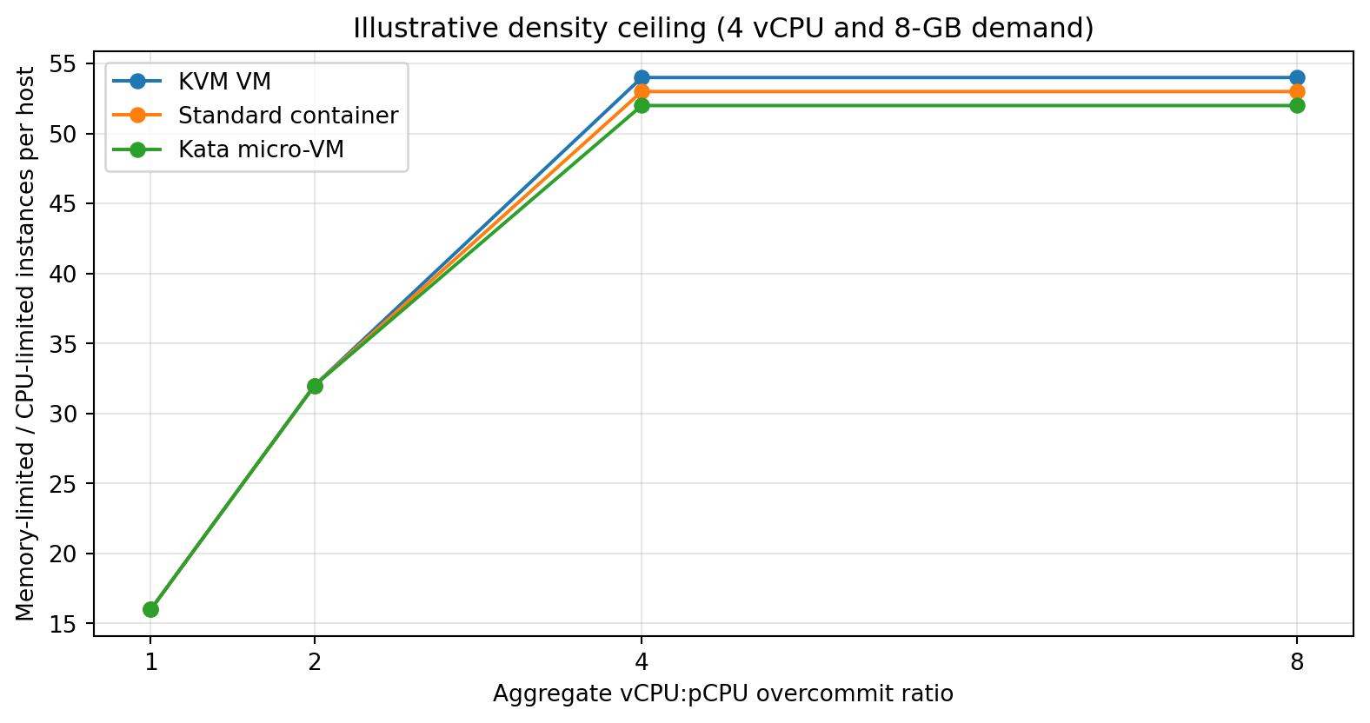
Figure 5. Analytical density ceiling under the stated memory assumptions.
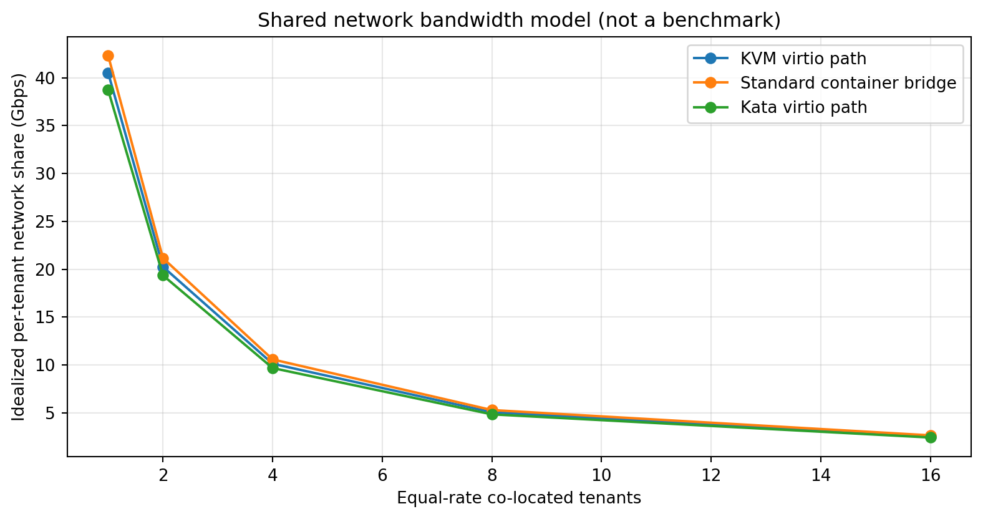
Figure 6. Idealized equal-share network model, not a benchmark.

3.3: Build a Quantitative Performance Model

Worked density and SLA example
The model's density ceiling is a resource upper bound. To keep degradation within 10% relative to the fair-share entitlement, require h_a + s − h_a s ≤ 0.10. At s = 0, the assumed architecture overheads satisfy this simple CPU-only criterion. If steal time reaches 8%, the combined KVM penalty becomes 11.68% because 1 − (1 − 0.04)(1 − 0.08) = 0.1168. That exceeds the 10% target. The admission controller should therefore reduce placement density or reserve CPU for the sensitive pool when measured steal time rises.
For a worked example, choose R = 2 and 32 instances per host. KVM has a nominal 2-core share per instance and an effective 1.92 cores at zero steal. Standard containers have 1.95 and Kata 1.88. All remain below the 54/53/52 memory ceilings. At R = 4, the resource count rises to the memory ceiling, but each instance's fair-share entitlement falls below one core. A latency-sensitive SIS database should not be placed at R = 4 merely because the memory calculation permits it.
The recommended planning point is R = 1 or 2 for SIS/LMS, with CPU reservations and NUMA-aware placement. Research pools can use R = 2 to 4 only when job queues and quotas tolerate variable throughput. R = 8 is a theoretical density point, not a default production setting. The equations should be recalculated using measured h, s, memory footprint, network efficiency and application demand.
R | CPU-limited instances | KVM density | Container density | Kata density
1:1 | 16 | 16 | 16 | 16
2:1 | 32 | 32 | 32 | 32
4:1 | 64 | 54 | 53 | 52
8:1 | 128 | 54 | 53 | 52

TASK 4: Analyse Performance Under Different Operating Conditions

Best-case conditions
The best case for KVM is a CPU-bound application with long-running compute phases, virtio devices, local NUMA placement, no memory overcommit and low vCPU contention. Guest code executes directly on the processor for most of its runtime. EPT/NPT reduces the need for software shadow page-table management. Virtio avoids much of the cost of emulating legacy devices. With reserved CPU and sufficient RAM, tail latency is dominated by the application and physical device rather than the hypervisor.
Standard containers perform best when the application is compatible with the host kernel, uses few privileged operations, has a predictable memory footprint and does not saturate the virtual network. Since there is no guest boot or guest-kernel boundary, startup and memory overhead are low. Cgroup CPU and memory controls provide enforceable quotas. Kata performs best when a workload runs long enough to amortise micro-VM startup and guest-kernel memory, uses virtio devices efficiently and receives a stable vCPU allocation.
For all three, the best placement is NUMA-local and avoids oversubscribing memory bandwidth, NVMe queues and NIC queues. The best case is not simply an idle host; it is a host with balanced resource placement and no cross-tenant contention. Registration traffic should be load-tested using realistic request distributions and a warmed database cache.
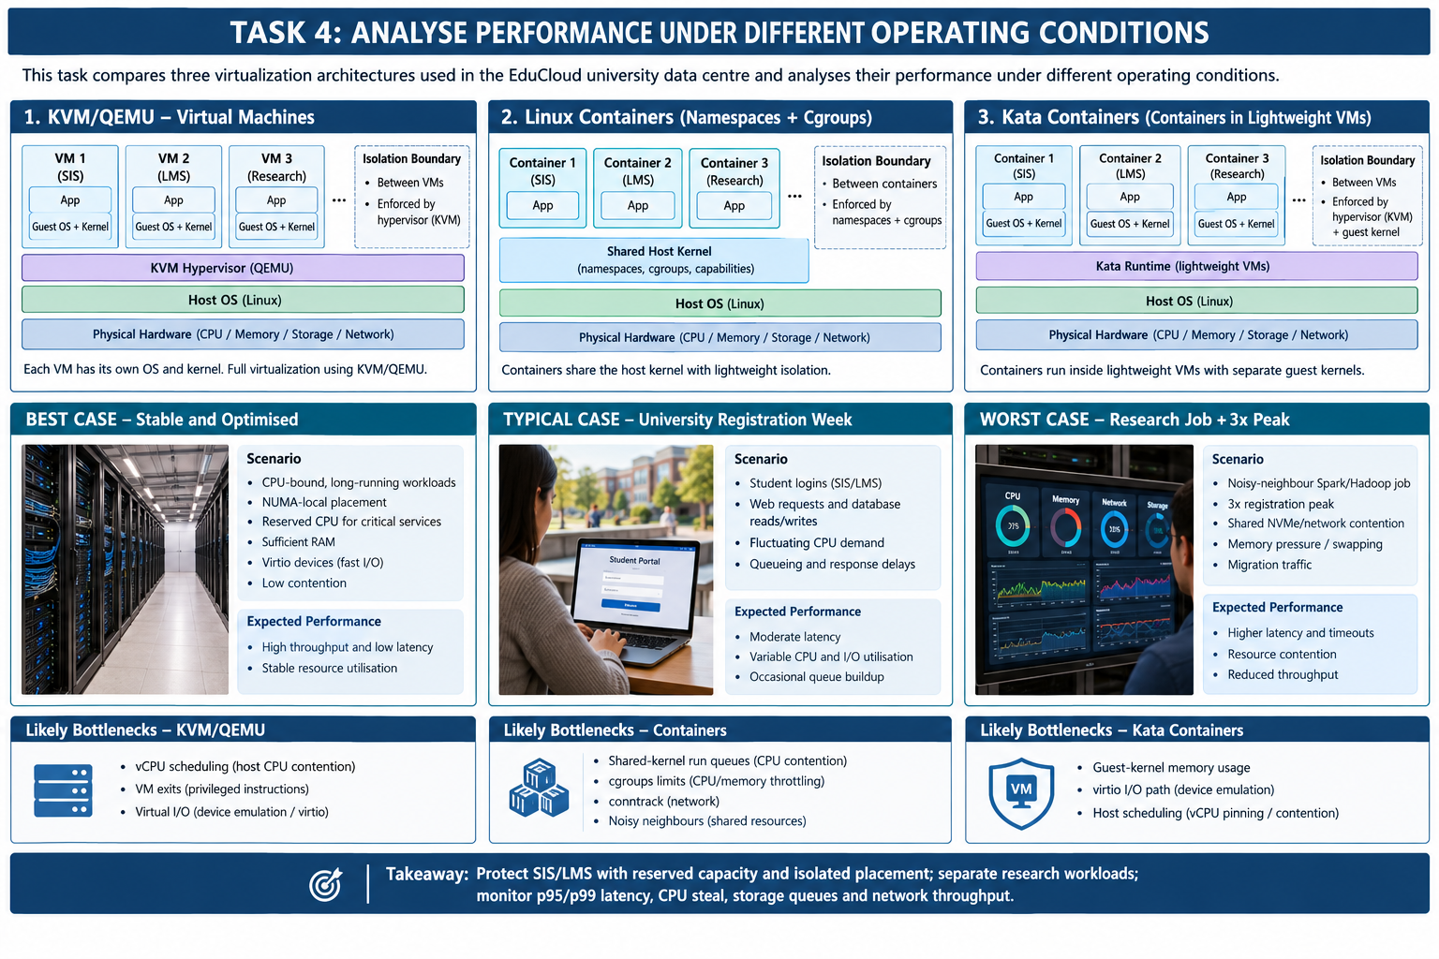

4.1: Analyse Performance Under Different Operating Conditions

Typical case: registration-week web and database load
A typical registration week combines bursts of login requests, short web transactions, database reads and writes, background jobs and API calls. CPU utilisation fluctuates, while latency is sensitive to queueing and database lock contention. KVM isolates guest kernels, but each VM still competes for pCPU time, memory bandwidth, storage queues and virtual-switch capacity. If vCPU demand temporarily exceeds physical cores, the scheduler accumulates runnable vCPUs and guest CPU steal time rises. The user sees slower page loads and failed logins even when average host CPU utilisation appears acceptable.
Containers start quickly and may show good average throughput, but many containers sharing one kernel can create run-queue pressure, conntrack pressure and noisy-neighbour effects. A container with a high CPU quota can consume cycles needed by the login service unless quotas and priorities are correctly configured. Kata adds a VM boundary but incurs extra memory and virtual I/O processing. For short-lived web processes, startup and guest service overhead can be visible; for steady application servers, it is amortised.
The Task 3 model predicts that the CPU entitlement per 4-vCPU instance falls from 3.84 KVM cores at 1:1 to 1.92 at 2:1 and 0.96 at 4:1, before steal. A registration service should therefore remain at 1:1 or 2:1 with reserved capacity. The university should monitor p95 and p99 latency, not only mean response time, and should isolate database storage I/O from batch shuffle traffic.
4.2: Analyse Performance Under Different Operating Conditions

Worst case: noisy neighbour, swapping and migration
In the worst case, a research workload performs a shuffle-heavy Spark job while registration traffic peaks at three times normal. The Spark job generates sustained network traffic and high-volume reads/writes. Shared NVMe queues, virtual switches and memory bandwidth become contention points. KVM's vCPU scheduler can delay SIS vCPUs; virtio queues and host back ends add further queueing. If memory overcommit triggers ballooning or swapping, random page faults and storage I/O can cause severe tail-latency spikes.
A standard container shares the host kernel and its I/O paths. A container that is allowed excessive CPU, memory or network resources can degrade sibling containers. A kernel-level exploit in an external workload can cross the container boundary. Kata adds a guest-kernel boundary, but it does not isolate the physical NIC, NVMe device, host kernel or management plane. Host-level queue contention remains possible, and a compromised VMM or host back end remains a risk.
Live migration during peak load adds dirty-page copying, network traffic and possible CPU throttling. If migration competes with registration traffic, latency rises. Migration should be rate-limited and scheduled outside the peak window where possible. If emergency patching is required, move one host at a time, reserve migration bandwidth, verify guest health and retain rollback capacity. The worst-case response is placement isolation, resource reservation and back-pressure, not simply increasing overcommit.
4.3: Analyse Performance Under Different Operating Conditions

Condition comparison and operational actions
Best-case placement should use local memory, reserved CPU and virtio or native fast paths. Typical registration load requires headroom for bursts and separate database I/O classes. Worst-case load requires host-pool separation, per-tenant quotas, network shaping and migration controls. The performance degradation is non-linear near saturation because queue wait time rises rapidly as utilisation approaches 100%. A simple equal-share model is useful for entitlement but cannot predict all queueing effects.
The operations team should define thresholds: CPU steal above 5% for five minutes triggers placement review; p95 login latency above the service target triggers admission throttling; sustained NIC or storage queue saturation triggers traffic shaping; and any swapping on the SIS pool triggers immediate investigation. Thresholds are proposed operational controls and must be calibrated against baseline measurements. They are not claims about current EduCloud telemetry.

TASK 5: Security Threat and Vulnerability Analysis

Threat model scope and assets
The protected assets are student identity records, enrolment and examination records, grades, authentication tokens, research datasets, VM images, backups, encryption keys and management credentials. Adversaries include a compromised student account, a malicious or compromised departmental administrator, an external research collaborator, a compromised container image, and an attacker exploiting a hypervisor, runtime or virtual-network flaw. The security objectives are confidentiality, integrity and availability. The trust boundaries differ: KVM separates guest kernels; containers share a host kernel; Kata adds a guest kernel and a VM boundary.
The attack surface includes hypervisor code, QEMU device emulation, KVM interfaces, guest kernels, host kernel, container runtime daemon, namespaces/cgroups configuration, VM images and snapshots, storage back ends, virtual switches, orchestration APIs, migration channels and backup systems. Management-plane compromise is especially serious because an attacker may alter images, attach disks, change network policy or access snapshots across tenants.
The threat model assumes the host administrator and control plane are highly privileged and therefore require MFA, least privilege, audited access and separation of duties. No architecture can compensate for an unrestricted administrator account. The university should classify SIS and examination systems as high sensitivity, departmental applications as internal, and external Spark/Hadoop workloads as untrusted.
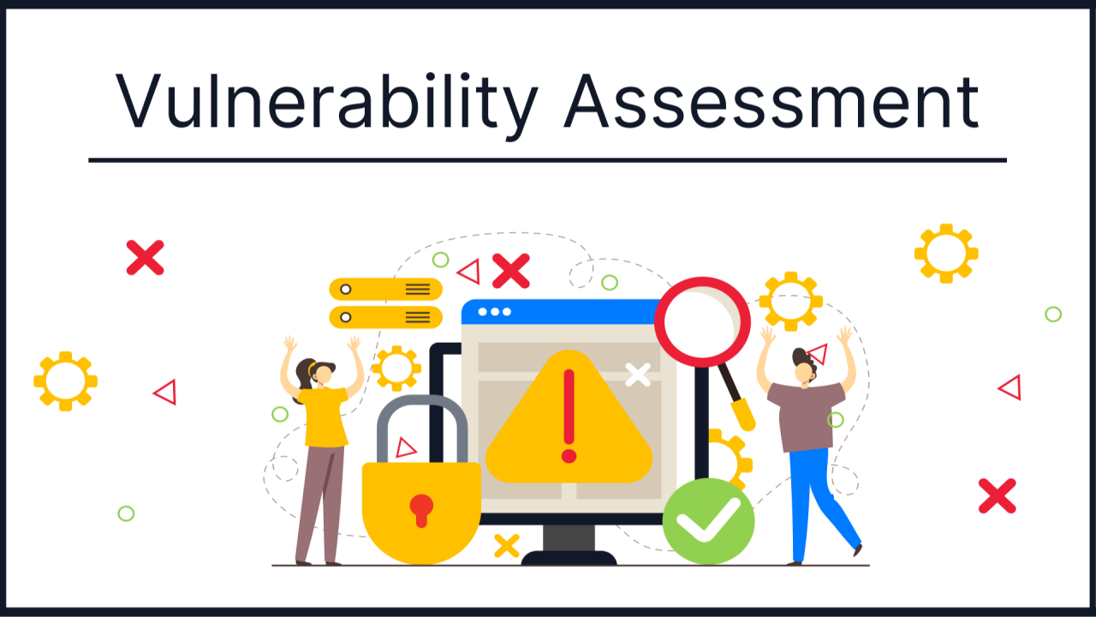
5.1: Security Threat and Vulnerability Analysis

Threat categories and comparative exposure
VM escape or hypervisor/VMM compromise: KVM has a larger guest-to-host interface through virtual devices and hypercalls, so QEMU and KVM must be patched and device models minimised. A successful escape can compromise the host and other VMs. Standard containers expose the shared host kernel directly through system calls, so a kernel privilege-escalation flaw can compromise all containers on that host. Kata reduces direct host-kernel exposure but still depends on KVM, VMM and host back ends.
Cross-tenant side channels: all three approaches can share CPU caches, memory bandwidth and other microarchitectural resources. VM boundaries do not automatically eliminate cache or speculative-execution side channels. Containers share even more kernel and scheduler state. Kata still shares physical CPU resources. Mitigations include dedicated hosts for the most sensitive services, SMT policy, CPU pinning and patching, with residual risk from shared hardware.
Image tampering and VM sprawl: freely copied images can contain outdated kernels, secrets or malware. VM snapshots can preserve credentials and sensitive data. This threat applies to all approaches; container images and VM images both need provenance, signing, vulnerability scanning, controlled registries and lifecycle ownership. Unpatched guest kernels are a direct concern in the scenario. Image reuse must be through a controlled pipeline, not ad hoc file copying.
Threat | KVM | Standard container | Kata | Primary impact
VM/container escape | VMM/device attack surface | Shared-kernel escalation | VMM + guest/runtime layers | C/I/A
Side channel | Shared CPU/cache | Shared kernel/CPU/cache | Shared CPU/cache | C
Image tampering | VM image/snapshot | Container registry/layers | Guest + container images | C/I
Network spoof/sniff | vNIC/vSwitch | veth/bridge/overlay | virtio-net/vSwitch | C/I
Insecure migration | Guest memory/state channel | Runtime/control-plane transfer | VM state + runtime channel | C/I

5.3: Security Threat and Vulnerability Analysis

Network, migration and availability threats
Virtual-network sniffing or spoofing can expose login tokens and database traffic if tenants share flat Layer-2 segments or permissive overlays. KVM and Kata rely on virtual NICs and host switching; standard containers rely on veth, bridge or overlay networks. Enforce tenant-specific VRFs/VLANs, security groups, anti-spoofing, mutual TLS for service calls and deny-by-default east-west rules. External research tenants must not route to SIS database subnets.
Insecure live migration can expose guest memory and state if migration traffic is unauthenticated, unencrypted or reachable from tenant networks. The control plane should use authenticated encrypted migration over a dedicated management network, restrict source and destination hosts, log events and validate certificates. Migration keys must be rotated and protected. Migration remains a privileged operation and should require approval for sensitive VMs.
Availability attacks include CPU exhaustion, memory pressure, fork bombs, packet floods, storage I/O storms and deliberate queue saturation. Containers can be especially exposed when cgroup limits are absent or misconfigured. KVM and Kata can also exhaust host resources through many guests or high I/O rates. Apply quotas, per-tenant rate limits, resource admission controls, circuit breakers and capacity headroom.
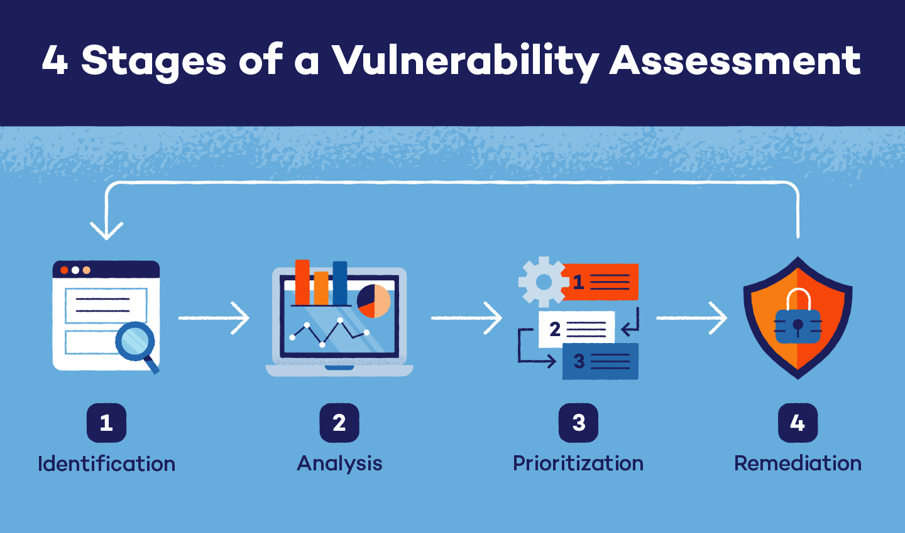

5.4: Security Threat and Vulnerability Analysis

CIA impact and security conclusion
Confidentiality impact: leakage of student records, passwords, session tokens, grades or examination materials. Integrity impact: unauthorised changes to enrolment, marks, fees or identity records. Availability impact: failed logins, unavailable registration, delayed examinations or data recovery. A single host-level compromise can affect multiple tenants, so the blast radius depends on placement and the control plane as much as on the runtime.
Relative exposure is not absolute. Standard containers are least suitable for untrusted external workloads because the host kernel is shared. KVM provides a strong, mature guest boundary but requires hardening of QEMU, migration and management. Kata improves isolation compared with a shared-kernel container, but it still shares the host and hardware. For SIS, use dedicated KVM hosts and strict management controls. For external research, use a separate host pool with Kata or dedicated VMs, independent storage keys and network segmentation.

TASK 6: Formulate the Isolation–Performance Trade-off

Decision variables and objectives
The decision must optimise resource efficiency without weakening SIS isolation or breaching the registration-week service target. Define binary placement variables x_{a,t,h}, where architecture a is selected for tenant class t on host h. Let n_{t,h} be the number of instances, R_h the host overcommit ratio, z_h indicate whether SMT is enabled, and d_h indicate whether a host is dedicated to SIS. Let q_{t,h} be reserved CPU, m_{t,h} reserved memory and b_{t,h} network bandwidth. Tenant classes are SIS/LMS, internal departmental and external research.
The primary objective is to minimise total operating cost while meeting security and performance constraints. A useful objective is J = C_host + C_ops + λ1·P_degradation + λ2·Risk_exposure + λ3·Migration_cost. C_host represents allocated hardware and capacity; C_ops represents patching, monitoring and image-management effort; P_degradation is the predicted service degradation; Risk_exposure weights the threat model; Migration_cost represents disruption and bandwidth used during maintenance. The weights λ are governance decisions and should be approved by the university, not chosen to hide trade-offs.
A secondary objective can maximise safe density: maximise Σ n_{t,h} subject to the constraints. Density is not maximised without qualification. A configuration that packs external workloads onto SIS hosts may have low cost but unacceptable risk and p95 latency. Therefore, the model uses hard security constraints for SIS and a bounded performance penalty for other pools.
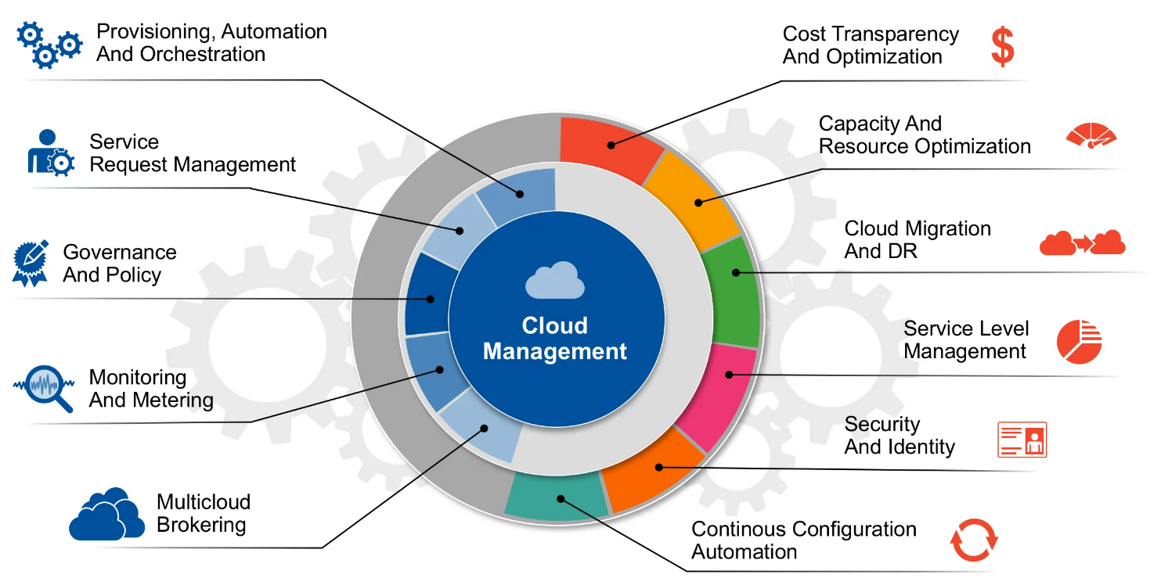

6.1: Formulate the Isolation–Performance Trade-off

Performance constraints from Task 3
For each host, total vCPU demand must satisfy Σ vCPU_i ≤ 64R_h. Effective per-instance CPU capacity is C_a(R_h,s_h) = (vCPU_i/R_h)(1−h_a)(1−s_h). The service constraint requires measured performance degradation D_{t,h} ≤ 0.10 for SIS at peak load. The CPU model alone is insufficient, so the full SLA also requires p95 login latency ≤ L_target, storage queue latency ≤ Q_target and network utilisation below a configured saturation threshold.
Memory constraints require Σ m_i + host reserve ≤ 512 GB. Using the 15% reserve assumption, workloads may consume at most 435.2 GB. The instance density is bounded by the memory ceilings derived in Task 3: 54 KVM VMs, 53 standard containers or 52 Kata micro-VM instances at 8-GB demand. These are approximate model ceilings, not production targets. A safe production count must include burst memory, page cache, guest kernel overhead and failure-recovery headroom.
Network constraints require Σ b_i ≤ 45 Gbps under the assumed 10% reserve across the two NICs. For SIS, reserve bandwidth and queue priority. For external Spark/Hadoop, enforce a per-tenant cap and use separate NICs, SR-IOV or dedicated network paths only where the operational and security model supports them. Storage bandwidth is constrained by the measured shared backend capacity; no fixed NVMe throughput is assumed because it is not specified.
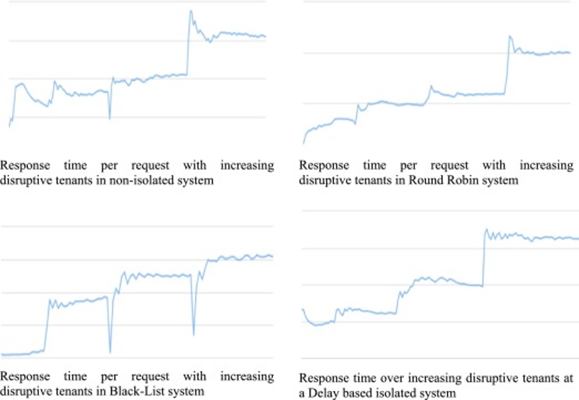

6.2: Formulate the Isolation–Performance Trade-off

Isolation constraints and cost function
The hard security constraint is that external research workloads cannot share the SIS host pool or have a network path to SIS databases. Standard containers are disallowed for external untrusted code on SIS hosts. SIS uses dedicated KVM placement with encrypted disks, signed images, secure migration and audited administrative access. Departmental containers are permitted only with restricted capabilities, seccomp, cgroups and approved images. External workloads use Kata or dedicated VMs on isolated hosts.
An example decision score for a candidate placement is Score = 0.30·CPU_cost + 0.20·Memory_cost + 0.20·Network_cost + 0.20·Risk_score + 0.10·Operations_cost, with each term normalised to [0,1]. The exact weights are illustrative and should be calibrated by stakeholders. Hard isolation rules are not traded away by a low score. If a candidate violates an isolation constraint, it is rejected regardless of density.
The practical solver can begin as a policy-based admission controller rather than a complex integer-programming engine. Classify workload, check allowed architecture, check reserved CPU/memory/network, estimate density and then place. Re-evaluate after every peak event and migration. This is transparent, auditable and can be implemented using existing orchestration labels, affinity rules and resource quotas.
6.3: Formulate the Isolation–Performance Trade-off

Sensitivity and recommended operating region
At R = 1 or 2, the model provides 16 or 32 four-vCPU instances per host before memory becomes limiting. At R = 4, memory limits the host to approximately 52–54 instances, but each instance receives less than one effective core under the illustrative model. SIS should remain at R ≤ 2 and use CPU reservations. External batch workloads can use higher ratios only if queueing and completion-time targets permit it.
The trade-off is sensitive to actual active CPU duty cycle. If research jobs run continuously at high utilisation, overcommit creates real contention. If departmental jobs are mostly idle, statistical multiplexing can be efficient. Therefore, admission control should use measured 95th-percentile CPU demand rather than allocated vCPU count alone. Memory is less safely overcommitted for databases because swapping creates severe latency spikes.
The selected policy is a segmented hybrid: dedicated KVM hosts for SIS/LMS and examination services; standard containers for trusted internal services; Kata or dedicated KVM for external collaborators. This does not maximise raw density, but it meets the hard isolation requirement and gives each workload class a clear performance envelope.

TASK 7: Evaluate Mitigation Strategies

Mitigation 1: dedicated host pools and micro-segmentation
Dedicated SIS host pools directly address cross-tenant compromise, noisy neighbours and accidental data exposure. SIS VMs are placed only on approved KVM hosts. External research workloads run on a different pool. Separate VRFs/VLANs, security groups and firewall policies prevent external tenants from reaching SIS database and management subnets. This reduces the blast radius even if an external guest or runtime is compromised.
Residual risk remains from shared control-plane credentials, backup systems, storage administrators, physical network infrastructure and vulnerabilities in the hypervisor or firmware. Dedicated hosts do not eliminate side channels if physical hardware is still shared through a common cluster or management domain. Administrative access must therefore be segmented and audited.
The capacity cost is explicit: reserving a fraction of the 16 hosts for SIS reduces the pool available to research. For example, reserving four hosts means 25% of host capacity is unavailable to other tenants. This is a placement cost, not a CPU overhead percentage. The SIS trade-off is acceptable because confidentiality and availability are hard requirements. Use host affinity and anti-affinity rules and maintain N+1 capacity for failures.

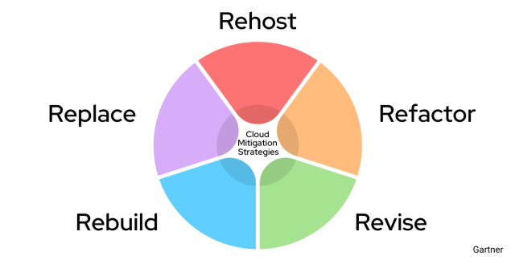

7.1: Evaluate Mitigation Strategies

Mitigation 2: signed images, patching and immutable build pipeline
A controlled image pipeline addresses outdated guest kernels, copied VM images and container image tampering. Build golden images from approved sources, scan packages, remove embedded secrets, sign the final artifact and enforce signature verification before deployment. Record image digest, owner, build time, kernel version and patch status. Disallow direct copying of VM disks or container layers between teams. Rebuild rather than manually modifying long-lived images.
Residual risk remains from compromised upstream packages, zero-day vulnerabilities, stolen signing keys and runtime misconfiguration. Signing proves provenance and integrity relative to a trusted key; it does not prove that the image is safe. The pipeline needs key rotation, protected signing infrastructure, vulnerability scanning, emergency patching and periodic runtime attestation.
The direct CPU cost is small during steady-state execution; the main cost is image scanning and deployment time. If the pipeline adds 30 seconds to a deployment, that is a lifecycle delay, not a continuous application slowdown. The university should accept this cost for all SIS and external workloads. Guest kernel patching must be tracked as a compliance metric, with exceptions expiring automatically.
7.2: Evaluate Mitigation Strategies

Mitigation 3: restrict kernel attack surface and runtime privileges
For standard containers, drop unnecessary Linux capabilities, run as non-root, enable seccomp and mandatory access controls, avoid privileged mode, restrict host mounts and apply CPU, memory and PID cgroup limits. For KVM, minimise QEMU device models, use virtio where suitable, restrict management sockets and keep host and guest kernels patched. For Kata, restrict the guest-agent channel, minimise host mounts and isolate VMM processes.
Residual risk remains from kernel and runtime vulnerabilities, misconfigured capabilities, side channels and shared hardware. gVisor is an alternative sandbox runtime that intercepts system calls using a userspace Sentry; its documentation notes that the Sentry implements application-facing system calls and uses a Gofer for file access. This reduces direct host syscall exposure but introduces compatibility and performance considerations. [4][5]
The performance cost must be measured by workload. Seccomp and capability dropping generally impose limited steady-state overhead for common paths, but syscall interception or sandboxed filesystem paths can add cost. Do not assign a universal percentage. Compare native, standard container and sandboxed execution using the same syscall-heavy and I/O-heavy workload. Accept modest overhead for untrusted external code; do not apply a costly sandbox indiscriminately to every trusted SIS component.

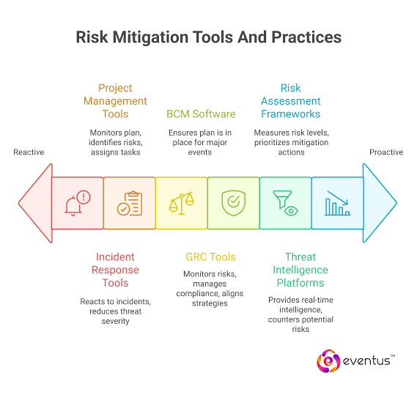
7.3: Evaluate Mitigation Strategies

Mitigation 4: side-channel controls and secure migration
Disable SMT for the highest sensitivity host pool where threat assessment requires it, apply current microcode and kernel mitigations, pin critical vCPUs and avoid co-scheduling unrelated tenants on sibling threads. This reduces some cross-thread contention and side-channel exposure but does not eliminate all shared-cache or speculative-execution risks. SMT disablement can reduce available logical CPU capacity, so the effective schedulable capacity may fall toward physical-core count.
For live migration, use an authenticated and encrypted management channel, restrict migration to dedicated management interfaces, verify destination host identity and log the full lifecycle. Reserve migration bandwidth and prohibit external tenants from initiating migration. Migration should be staggered during peak load. Residual risk includes compromised management credentials, implementation defects and denial of service against the migration network.
A quantified first-order estimate for disabling SMT is not possible from the assignment data because the number of logical threads per core and workload scaling are not specified. The safe statement is that capacity falls from the SMT-enabled measured baseline to the physical-core-only baseline; measure this delta. For an illustrative planning penalty, use 10% lower throughput only as a sensitivity case, not a fact, and replace it with benchmark data. The mitigation is acceptable for SIS if the reserved pool has sufficient headroom.
Mitigation | Threat reduced | Residual risk | Performance/density cost
Dedicated SIS pool | Cross-tenant access/noisy neighbour | Admin, firmware, side channel | Capacity reserved; e.g. 4/16 hosts
Signed images + patching | Tampering/outdated kernels | Zero-days, key compromise | Build/scan/deploy delay
Least privilege + seccomp | Container escape surface | Kernel/runtime defects | Workload-dependent syscall cost
SMT policy + encrypted migration | Side-channel/migration exposure | Other shared hardware/control risks | SMT capacity loss; crypto CPU cost

TASK 8: Implement and Test

Environment design and fairness controls
The experiment compares KVM/QEMU, standard Docker or Podman containers, and Kata Containers. The assignment permits nested virtualization on a laptop if documented. Record host CPU model, core count, RAM, kernel, hypervisor version, storage device, filesystem, NIC speed, nested-virtualization status and power profile. Do not compare a VM with four vCPUs against a container with unrestricted CPU. Use identical 4-vCPU-equivalent limits, 8-GB memory limits where feasible, the same dataset, same workload version and same number of repetitions.
The scale sequence is 1, 2, 4, 8 and 16 instances. If the laptop cannot safely run 16 instances, document the maximum stable count and explain the hardware limit. Stop the experiment before memory pressure or thermal throttling makes the host unstable. Run a bare-metal baseline first, then each architecture. Reboot or allow a cooldown between runs if thermal conditions materially change.
KVM can be tested with QEMU/KVM or VirtualBox if KVM is unavailable, but VirtualBox is not identical to the production Type-1 architecture. Label the result accurately. Standard containers can be tested with Docker or Podman. Kata requires a supported Linux host and hardware virtualization; a Windows laptop may need a Linux VM with nested virtualization, which adds an extra layer and changes the measured result. Document that limitation.
8.1: Implement and Test

Reproducible setup commands
On an Ubuntu test host, install the tools with: sudo apt update; sudo apt install -y qemu-kvm libvirt-daemon-system virtinst docker.io podman sysbench fio iperf3 stress-ng linux-tools-common. Check virtualization with: lscpu | grep Virtualization; egrep -c '(vmx|svm)' /proc/cpuinfo; lsmod | grep kvm. For Docker, check: docker info. For cgroups, inspect: mount | grep cgroup. For Kata, follow the official distribution-specific installation guide and run kata-runtime check or the current equivalent for the installed release. [1][6]
Create a dedicated test directory and record the exact command line, image digest and configuration for every run. Example container: docker run --rm --cpus=4 --memory=8g --name bench ubuntu:24.04 sleep 3600. Example CPU test inside the instance: sysbench cpu --threads=4 --time=60 run. Example memory pressure: stress-ng --vm 1 --vm-bytes 6G --timeout 60s. Example disk test on a disposable test file: fio --name=randread --filename=/tmp/fio.test --size=2G --rw=randread --bs=4k --iodepth=16 --runtime=60 --time_based --group_reporting. Never point fio at a production disk or raw device.
For network testing, run iperf3 -s on a separate endpoint and iperf3 -c SERVER_IP -P 4 -t 60 from each instance. Use the same endpoint and avoid testing over Wi-Fi if the purpose is to isolate virtualization overhead. For host monitoring, capture mpstat -P ALL 1, pidstat -u -r -w 1, iostat -xz 1, sar -n DEV 1 and vmstat 1. Record CPU steal, context switches, run queue, memory pressure and device latency.

Workload | Command / method | Primary metric
CPU | sysbench cpu --threads=4 --time=60 run | events/s, CPU time
Disk | fio random read/write on disposable file | IOPS, MB/s, p95 latency
Network | iperf3 -c SERVER_IP -P 4 -t 60 | Gbps, retransmits
Memory | stress-ng --vm 1 --vm-bytes 6G --timeout 60s | completion time, RSS
Noisy neighbour | Target benchmark + stress-ng on sibling | p95 latency delta
Security | lsns, cgroup files, seccomp status, route test | isolation evidence

8.2: Implement and Test

Noisy-neighbour and security validation
For the noisy-neighbour test, run a steady benchmark in one target instance while a second instance on the same host runs stress-ng CPU, memory and I/O load. Repeat with the noisy neighbour stopped. Keep the target's resource limit unchanged. Record target throughput and p95 latency before, during and after interference. Run at least five repetitions per condition if time permits. Do not compare a target running alone on one architecture with a target running alongside a noisy neighbour on another.
For a container isolation check, inspect namespaces using lsns and read /proc/PID/status. Confirm the container has a distinct PID and network namespace, a non-root UID, dropped capabilities and cgroup limits. For KVM, inspect virsh dominfo, virsh vcpupin and the VM's XML. For Kata, verify that a separate guest kernel is active and that the workload is inside the micro-VM. These checks demonstrate configuration, not proof against every exploit.
For security validation, record kernel versions, runtime versions, image digests and whether seccomp is active. Verify network policy by attempting a permitted service connection and a prohibited connection to a test-only SIS-like subnet. Use a controlled lab endpoint, never production student records. Save terminal output and screenshots with timestamps. Redact IPs, usernames, keys and other secrets before including evidence in the report.

8.3: Implement and Test

Test matrix and reproducibility checklist
Run CPU, disk, network and memory tests at each instance count. For each, collect at least five repetitions where practical. Use the same benchmark duration and warm-up. Report mean and standard deviation. For latency, report mean and p95. For throughput, report operations per second, MB/s or Gbps with units. Record instance startup time and idle memory footprint. Record baseline values from bare metal using the same workload.
The comparison is invalid if a run is affected by background Windows updates, antivirus scans, cloud sync, thermal throttling, different CPU governor settings or network congestion. Record these conditions rather than silently excluding them. Use a dedicated test directory and clean up test files after each run. Do not use the system drive for repeated high-volume fio writes without considering SSD wear.
The final evidence package should include host specification screenshot, virtualization configuration, container or VM launch commands, workload commands, raw CSV output, monitoring logs, security validation output and two graphs. Task 9 provides the report format. Task 10 explains how to compare measurements with the model.


TASK 9: Record Experimental Performance

Metrics and collection protocol
Task 9 requires measured performance, not estimated values. The assignment's evidence checklist specifically expects actual comparative measurements, at least one table and two graphs, multiple repetitions and variability. The current document therefore does not fabricate a result. Populate the data table after running the Task 8 procedure. For each architecture and instance count, collect CPU throughput, disk throughput and latency, network throughput, memory-test result, startup time, idle memory footprint, CPU steal time and context switches. For request-oriented workloads, include mean and p95 latency.
Use at least five repetitions per cell where hardware and time permit. Let x_i be the measurement from repetition i. Report mean x̄ = Σx_i/n and sample standard deviation s = sqrt(Σ(x_i−x̄)²/(n−1)). For throughput, larger is better. For latency, smaller is better. Do not average p95 values from unrelated percentiles without retaining the raw samples or explaining the method. If the tool exports per-run p95, report the mean of the run-level p95 values and label it clearly.
Performance degradation versus bare metal is D = 100 × (1 − T_virtual/T_baremetal) for throughput. For latency, use L_increase = 100 × (L_virtual/L_baremetal − 1). These are different measures and should not be mixed. For startup time, report the time from launch command to service-ready signal, not merely process creation.
9.1: Record Experimental Performance

Results table: populate with measured values
The table below is deliberately blank. Enter the mean ± standard deviation from your own runs. Use one row per architecture and instance count. If a test cannot be run for a platform, mark it N/A and explain why. Do not fill missing cells with the analytical values from Task 3. Retain raw CSV files so that the graphs can be regenerated.
A useful minimum table includes CPU events/s, fio read MB/s, iperf3 Gbps, memory workload completion time, p95 latency, CPU steal, context switches/s, startup seconds and idle memory GB. Add a bare-metal row for baseline. Use consistent units and identical benchmark duration. Record whether security mitigations were enabled for each run.
After data entry, interpret whether the measured density is limited by CPU, memory, storage or network. A host may support 16 instances but show unacceptable p95 latency at 8 because the shared disk queue saturates. The first resource to saturate determines the practical density, not the nominal vCPU count.

Architecture | Instances | CPU events/s mean ± SD | fio MB/s mean ± SD | iperf Gbps mean ± SD | p95 latency ms
Bare metal | 1 | PENDING | PENDING | PENDING | PENDING
KVM | 1 / 2 / 4 / 8 / 16 | PENDING | PENDING | PENDING | PENDING
Container | 1 / 2 / 4 / 8 / 16 | PENDING | PENDING | PENDING | PENDING
Kata | 1 / 2 / 4 / 8 / 16 | PENDING | PENDING | PENDING | PENDING

9.2: Record Experimental Performance

Graph 1 and Graph 2: required comparisons
Graph 1 should show throughput versus number of co-located instances for KVM, standard containers and Kata. Use one line per architecture and include error bars representing standard deviation. If the y-axis mixes different metrics, create separate plots for CPU throughput, disk throughput and network throughput. The graph should show whether throughput scales linearly, plateaus or falls under contention.
Graph 2 should show p95 latency under interference. Plot target-service p95 latency for isolated baseline, normal co-location and noisy-neighbour conditions. A grouped bar chart or line chart is acceptable. Include the no-mitigation and mitigation cases if you tested a security control. Explain the benchmark's request rate and the target instance count in the caption.
The included figures in this report are analytical model illustrations, not experimental plots. Replace or supplement them with graphs generated from your measured CSV. The rubric expects measured results; leaving the fields blank means this evidence remains incomplete. A truthful report is stronger than invented benchmark numbers.
Figure 7. Example analytical curve only. Replace with measured throughput-versus-instance-count graph.
Figure 8. Example analytical sharing curve only. Replace with measured network or latency-under-interference graph.
9.3: Record Experimental Performance

Data quality, variability and interpretation
Use a stable test host and repeat each measurement. Report coefficient of variation CV = 100 × s/x̄ to identify noisy measurements. A high CV may indicate thermal throttling, background tasks, cache effects or unstable network conditions. Investigate rather than deleting inconvenient runs. If a run is invalid due to a documented external event, retain it in the raw data and explain the exclusion rule.
For a mitigation comparison, measure the same workload with the control disabled and enabled. For example, compare standard KVM placement with and without CPU pinning or compare container runtime with and without syscall sandboxing. Do not claim a mitigation is effective solely because it is enabled; verify the security property and quantify its performance cost.
Evidence to attach: terminal output for each benchmark, CSV files, monitoring logs, configuration files, host hardware screenshot and two final graphs. The evaluation form's implementation evidence chain also asks for screenshots, so capture actual command output and the relevant configuration panels. Do not use stock images as proof that a test was executed.

TASK 10: Compare Theory with Experiment

Prediction baseline
The Task 3 model predicts per-instance CPU capacity as C_a(R,s) = (4/R)(1−h_a)(1−s). It predicts memory ceilings of approximately 54 KVM VMs, 53 standard containers and 52 Kata instances using the stated 15% reserve and illustrative per-instance memory overheads. It predicts equal-share network throughput using 45 Gbps usable aggregate bandwidth and architecture-specific path efficiency assumptions. These are first-order estimates intended to expose bottlenecks and compare trends.
The model predicts that CPU entitlement halves when overcommit doubles. It also predicts that memory, rather than CPU, caps density at R = 4 and R = 8 for the 8-GB instance assumption. Standard containers are expected to have the lowest runtime overhead, while Kata has additional guest-kernel and virtual I/O costs. KVM has a separate guest-kernel boundary and device path. These are hypotheses to test, not conclusions that measured data must reproduce.
Once Task 9 measurements are entered, create a comparison table with predicted value, measured mean, standard deviation, absolute error and percentage error. For a non-zero prediction, percentage error is 100 × |measured−predicted|/predicted. If the prediction is zero or a bound, report absolute difference or whether the measurement violates the bound.
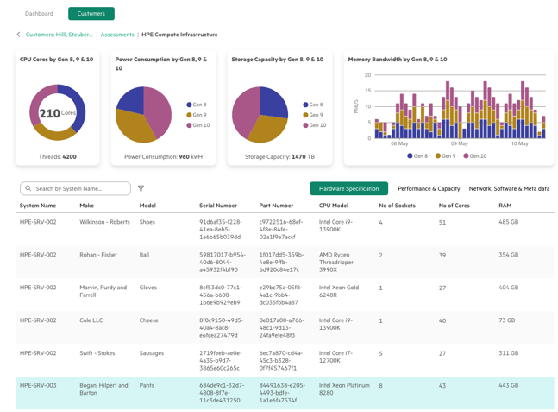
10.1: Compare Theory with Experiment

Explaining agreement or disagreement
If throughput falls approximately with 1/R, the CPU entitlement model is directionally supported. If throughput plateaus earlier, the likely causes include storage or network saturation, host scheduler overhead, memory bandwidth contention or thermal throttling. If throughput remains higher than predicted, the assumed overhead factor may be conservative, or the benchmark may not exercise the expensive path. If p95 latency increases sharply while mean throughput remains stable, queueing and burst contention are likely.
A container may outperform KVM on syscall-light CPU tests because it avoids a guest kernel and virtual device layer. It may lose that advantage on shared-kernel contention or network-heavy tests. Kata may have a higher startup time and memory footprint but similar steady-state compute throughput after the sandbox is running. The result depends on the workload and whether the guest is nested inside another hypervisor.
A laptop experiment with nested virtualization may show higher KVM and Kata overhead than production bare metal. The outer hypervisor schedules the test VM, while the inner hypervisor schedules nested guests. Cache and TLB behaviour, virtual interrupts and device emulation can differ. This is a valid lab limitation if documented, but it must not be presented as a direct measurement of the 64-core EduCloud host.
10.2: Compare Theory with Experiment

Quantitative error analysis template
For each metric, compute predicted P, measured mean M and standard deviation s. Absolute error E_abs = |M−P|. Relative error E_rel = 100 × E_abs/|P|. For CPU capacity, compare in cores or throughput-normalised units. For network throughput, compare Gbps. For latency, compare milliseconds. Avoid comparing modelled CPU cores directly with a benchmark's requests per second unless a calibration relationship is established.
A sample interpretation format is: “At four instances, measured container CPU throughput was M ± s, compared with model prediction P. The relative error was E%. The measured trend agreed/disagreed with the predicted direction because…”. Insert actual values only after running the tests. This report intentionally leaves placeholders rather than making up M and s.
If model error is large, revise one assumption at a time. Estimate h_a from a matched baseline; measure actual memory footprint; measure usable network bandwidth; and separate storage queueing from virtualisation overhead. Do not tune multiple parameters simultaneously to force a fit. Keep the original model and revised model so the evaluator can see the reasoning.

Metric | Prediction P | Measured mean M | Std dev | Absolute error | Relative error
CPU throughput | ENTER | ENTER | ENTER | |M−P| | 100×|M−P|/|P|
Disk MB/s | ENTER | ENTER | ENTER | |M−P| | 100×|M−P|/|P|
Network Gbps | ENTER | ENTER | ENTER | |M−P| | 100×|M−P|/|P|
p95 latency | ENTER | ENTER | ENTER | |M−P| | 100×|M−P|/|P|

10.3: Compare Theory with Experiment

Security conclusion after measurement
Performance measurements can change the placement decision but cannot prove isolation. If standard containers scale better, that does not make them appropriate for untrusted external research jobs. If Kata's throughput is close to KVM, it strengthens the case for Kata in the external pool. If Kata's memory overhead is too high, dedicated KVM VMs may be preferable. The threat model still requires a separate external pool, network segmentation and protected management plane.
If noisy-neighbour tests show substantial SIS-like latency degradation, increase reservation headroom, enforce traffic shaping and separate the host pools. If the mitigation causes a material performance penalty, evaluate whether it can be scoped to the highest sensitivity pool rather than disabled globally. Security decisions must be based on risk and compliance constraints, not benchmark speed alone.
The final comparison should explicitly state which trends were supported, which were not, the largest quantitative error and the most plausible explanation. The final architecture in Task 11 should be updated if the measured evidence contradicts a key assumption. Until the tests are run, this task's empirical conclusion remains pending.

TASK 11: Recommend and Defend the Final Architecture

Recommendation summary
Recommend a segmented hybrid architecture. Run SIS, LMS, authentication and examination services on a dedicated Type-1 KVM host pool with reserved CPU and memory, encrypted storage, signed golden images, strict administrative access and secure live migration. Run trusted departmental stateless services in hardened standard containers where density and rapid deployment matter. Run external research collaborators' Spark/Hadoop workloads in a separate pool using Kata micro-VMs or dedicated KVM VMs, with independent network segmentation, storage credentials and resource quotas.
This design is more appropriate than a single universal runtime. Standard containers offer efficient density but share the host kernel and are not the preferred boundary for untrusted external code. KVM provides a mature guest-kernel boundary for core university systems. Kata adds an outer VM boundary to container workflows and is useful for less-trusted workloads. The architecture also avoids putting external batch traffic on the same host pool as latency-sensitive registration services.
The recommendation is conditional on validation. Task 3 gives a planning model, Task 8 defines reproducible tests, and Task 9 must be populated with measured data. The model suggests SIS should remain at 1:1 or 2:1 overcommit and that memory ceilings limit high-density placement. If measured p95 latency or steal time exceeds the SLA, lower density or add capacity.
11.1: Recommend and Defend the Final Architecture

Architecture and data paths
The central control plane manages identity, policy, image signing, monitoring and audit. It should be isolated from tenant networks and protected with MFA, role-based access, approval workflows and separate administrator accounts. The SIS pool has no direct ingress from external research tenants. Access to shared services passes through controlled APIs and identity-aware gateways. Logging is replicated to a protected destination and backups use separate credentials.
The departmental pool supports approved container images, restricted capabilities, cgroup quotas and micro-segmentation. The external research pool has dedicated storage namespaces and keys, restricted egress, rate-limited NIC queues and no direct route to student databases. Kata or dedicated VMs isolate guest kernels. Spark/Hadoop data transfer should use a controlled ingestion gateway with scanning, authentication, encryption and quotas.
The deployment diagram on the next page shows the separation. This is a logical design; physical implementation must include separate host placement, VLAN/VRF boundaries, storage access controls and management-plane policy. A label or Kubernetes namespace alone is not sufficient proof of physical and network isolation.
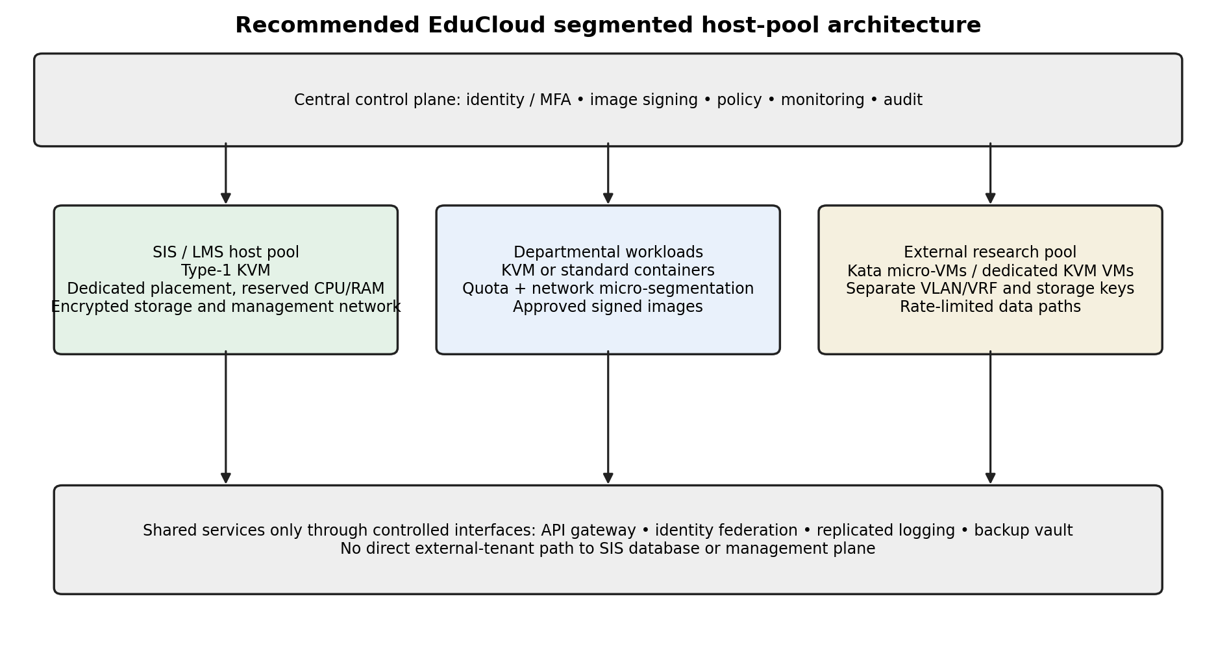
Figure 9. Recommended EduCloud host-pool and trust-boundary design.
11.3: Recommend and Defend the Final Architecture

Performance, security and operations
Performance: SIS uses reserved CPU and RAM with low overcommit, so registration bursts do not compete directly with Spark shuffle traffic. Departmental containers retain high density. External Kata workloads pay guest-kernel and virtio costs but receive a predictable resource envelope. The model estimates 16 or 32 four-vCPU instances per host at 1:1 or 2:1 before memory limits, but the actual safe count must be established with measured CPU, storage and network results.
Security: dedicated SIS hosts, separate external pools, signed images, guest patch compliance, network segmentation, encrypted migration and audited management reduce the main risks. Residual risks include hypervisor or host kernel zero-days, shared hardware side channels, control-plane compromise, supply-chain compromise and denial-of-service from resource exhaustion. The design requires continuous patching, vulnerability scanning and incident response.
Operations: maintain a small number of approved golden images, automate patching, monitor guest and host metrics, and use staged migration. Kata adds a guest kernel and runtime compatibility matrix. KVM requires hypervisor lifecycle management and image sprawl control. Standard containers require host kernel and runtime maintenance. The cost is operational complexity, but central policy and automation reduce manual drift.

11.4: Recommend and Defend the Final Architecture

Growth from 400 to several thousand instances
As EduCloud grows, scaling should be horizontal through host pools and automated placement rather than raising overcommit indiscriminately. Add hosts when CPU reservations, memory headroom, network queues or storage latency approach limits. Keep a capacity reserve for N+1 failure and maintenance. Use quotas by tenant and service class, and maintain a separate research capacity forecast based on job duration and shuffle intensity.
For several thousand instances, image management, observability, identity and network policy become as important as raw compute. Every image needs an owner, digest, patch SLA and retirement date. Every tenant needs a quota and a network policy. Every migration needs authenticated source/destination identity and an audit record. Automated compliance checks should block stale guest kernels and unsigned images.
The recommendation is practical if the university standardises the platform and automates lifecycle management. It is not cost-free: dedicated SIS hosts reduce the capacity available to other tenants, Kata consumes extra memory and operations must maintain multiple runtime classes. Those costs are justified by the sensitivity of student records and the changed external-tenant requirement.
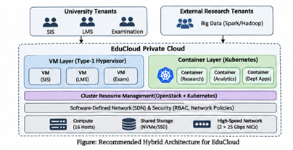
TASK 12: Re-evaluate and Adapt the Design: Day-4 Design Challenge

A. Impact analysis
The new requirement changes the original trust and workload assumptions. External research collaborators are less-trusted tenants, Spark/Hadoop jobs are I/O- and network-intensive and run for hours, registration peak load is approximately three times normal, hosts are patched through live migration, and regulation requires demonstrable isolation of student records. A design that allowed departmental and external workloads to share the same physical hosts or virtual network is no longer adequate for SIS.
Long-running Spark jobs can saturate storage and network queues, create sustained CPU demand and increase memory pressure during shuffle and aggregation. Unlike short web bursts, the load persists and may overlap with registration. If both workload classes share hosts and NIC queues, batch traffic can increase SIS tail latency even if average CPU remains moderate. The threat model also changes because external users can submit code, images and data that are not under university control.
The new regulation makes isolation evidence a requirement, not a best-effort design goal. The university must demonstrate host placement, network segmentation, storage access controls, key separation, identity policy, migration encryption and audit logs. Merely stating that tenants use separate containers is insufficient when containers share the host kernel.
12.1: Re-evaluate and Adapt the Design: Day-4 Design Challenge

B. Evaluate the original design
The original hybrid recommendation remains directionally sound, but any shared host placement between SIS and external research must be removed. Under a three-times registration peak, the SIS CPU demand and request rate rise. If the SIS pool was sized only for normal load, it may breach the 10% degradation target or p95 latency objective. The Task 3 model must be rerun with peak demand and reserved headroom. The 45-Gbps usable aggregate network estimate is only a theoretical host ceiling; real shuffle traffic and NIC queue contention require measurement.
KVM on a dedicated SIS host pool offers a separate guest kernel and clear placement boundary. Kata provides an additional guest-kernel boundary for external workloads, but it cannot prevent host-level network or storage contention if both pools share the same physical devices and queues. Therefore, the original design is adequate only after physical host-pool separation, independent network paths or strict QoS, separate storage access controls and encrypted migration are implemented.
The design should be evaluated against four tests: no external route to SIS data, no shared SIS/external host placement, bounded SIS p95 latency during a three-times peak, and verified encryption/authentication for migration. If any test fails, the design does not meet the new requirement. No claim of compliance should be made until the controls are tested and logged.

12.2: Re-evaluate and Adapt the Design: Day-4 Design Challenge

C. Adaptation and revised architecture
Modify the original design into three pools: (1) SIS/LMS/examination KVM pool on dedicated hosts; (2) internal departmental pool using KVM or hardened standard containers; and (3) external research pool using Kata micro-VMs or dedicated KVM VMs. Keep the control plane on a separate management network. Use independent VLANs/VRFs, firewall policy, storage namespaces and encryption keys. Deny all direct external-to-SIS paths and permit only explicitly approved data exchange through a gateway.
For big-data jobs, allocate dedicated NICs or SR-IOV virtual functions only after validating device isolation, IOMMU configuration and operational support. SR-IOV can reduce virtual-switch overhead but changes the migration and observability model; it must not bypass tenant security policy. Use traffic shaping and separate queues so research shuffle traffic cannot consume SIS-reserved bandwidth. Keep storage back ends separate where feasible, or enforce QoS and separate volumes/keys.
For patching, use authenticated encrypted live migration on a dedicated management network. Rate-limit migration and schedule maintenance outside registration peaks. Migrate one host at a time, validate VM health after cutover and preserve rollback capacity. If peak load makes migration unsafe, defer non-critical patching or add temporary capacity. The redesign reduces density because hosts are reserved by pool, but improves isolation and predictable latency.
Figure 10. Revised architecture with external research isolated from SIS/LMS.

12.3: Re-evaluate and Adapt the Design: Day-4 Design Challenge

D. Evidence-based defence and final decision
Retain the KVM foundation for SIS, modify placement and network/storage separation, and use Kata or dedicated KVM for external research. This is a modification rather than a total redesign because the original architecture already recognised the value of VM isolation and container density. The changed trust boundary requires stricter physical and logical separation. The model supports lower SIS overcommit and explicit resource reservations; the experiment must verify the peak-load target and noisy-neighbour isolation.
The defence rests on measurable evidence: Task 3 CPU and memory limits, Task 9 benchmark results, the noisy-neighbour experiment, a successful prohibited-network-path test, image signature verification, guest patch compliance and a test migration with encryption enabled. If measured p95 latency rises during a research stress test, the pool separation or QoS is insufficient and must be corrected before production. If Kata overhead is too high for the available research pool, use dedicated KVM VMs rather than reverting to shared-kernel containers.
The trade-off is deliberate. Host-pool separation reduces statistical multiplexing and increases hardware cost. Kata adds guest memory and virtual I/O overhead. Dedicated NICs and separate storage paths add operational complexity. These costs are acceptable because student-record confidentiality, integrity and availability are hard constraints. The final design remains scalable by adding hosts to the correct pool and automating policy, image lifecycle, monitoring and migration controls.
Requirement | Design control | Evidence to retain
External tenant isolation | Dedicated pool + Kata/dedicated VM | Host affinity, inventory, test report
No SIS data path | Separate VRF/VLAN + deny rules | Firewall and route test logs
3× registration peak | Reserved CPU/RAM/network + load test | p95 latency and capacity report
Live migration | Encrypted authenticated management channel | Migration config and audit log
Data protection | Separate storage keys and RBAC | Access policy and key audit

APPENDIX A: Benchmark capture template
The following shell template records basic host metrics. Run it on a disposable Linux test host, adapt the workload commands to the installed platform and save the output directory with the assignment evidence. It does not replace the detailed per-instance benchmark commands in Task 8.
#!/usr/bin/env bash
set -euo pipefail
OUT=${1:-results_$(date +%Y%m%d_%H%M%S)}
mkdir -p "$OUT"
{
date -Is
uname -a
lscpu
free -h
lsblk -o NAME,MODEL,SIZE,ROTA,TYPE
ip -s link
(command -v virsh >/dev/null && virsh version) || true
(command -v docker >/dev/null && docker version) || true
(command -v podman >/dev/null && podman version) || true
} > "$OUT/host_inventory.txt" 2>&1
timeout 120 mpstat -P ALL 1 > "$OUT/mpstat.txt" 2>&1 &
P1=$!
timeout 120 vmstat 1 > "$OUT/vmstat.txt" 2>&1 &
P2=$!
timeout 120 iostat -xz 1 > "$OUT/iostat.txt" 2>&1 &
P3=$!
wait $P1 || true; wait $P2 || true; wait $P3 || true
echo "Capture complete: $OUT"

APPENDIX B: Rubric completion matrix
Task | Required evidence | Included in this report | Still requires user execution
1 | Three architectures, labelled diagrams, trust boundaries | Yes | No
2 | Dominant overhead source for each approach | Yes | No
3 | CPU, memory, I/O, network and density derivations | Yes | Replace assumed overheads with measurements
4 | Best, typical and worst operating conditions | Yes | Validate with actual workload
5 | Threat model and architecture comparison | Yes | No
6 | Decision variables, objective and constraints | Yes | Calibrate weights with institution
7 | At least three mitigations with residual risk and cost | Yes | Measure runtime-specific costs
8 | Reproducible environment, commands, workloads, noisy-neighbour and security tests | Yes | Run commands and attach screenshots
9 | Actual comparative data, table, two graphs, mean ± SD | Template only | Mandatory benchmark execution
10 | Theory vs experiment and quantitative error | Method and template | Enter measured results
11 | Defended SIS/LMS recommendation and growth | Yes | Update with measured results
12 | External tenants, 3× peak, live migration and isolation | Yes | Validate controls and attach evidence

APPENDIX C: References
- [1] Kata Containers Documentation, “How it Works” and architecture overview. https://kata-containers.github.io/kata-containers/
- [2] Kata Containers Documentation, “Virtualization in Kata Containers.” https://kata-containers.github.io/kata-containers/design/virtualization/
- [3] Docker Documentation, “Docker Engine security.” https://docs.docker.com/engine/security/
- [4] gVisor Documentation, “What is gVisor?” https://gvisor.dev/docs/
- [5] gVisor Documentation, “Security architecture.” https://gvisor.dev/docs/architecture_guide/security/
- [6] Linux Kernel Documentation, “Running nested guests with KVM.” https://docs.kernel.org/virt/kvm/x86/running-nested-guests.html
- [7] Linux Kernel Documentation, “KVM entry and exit handling.” https://docs.kernel.org/core-api/entry.html

